TIS Technologies
TIS-BUS Automation Basics
Programming Guide – Ver.3.2
TIS Automation Technology
Last Rev: May 2015
Revision by
Daniel Bortolussi
Pritty K Thomas
Turath Mazloum

Contents

1- Introduction
Objective 1-1
TIS-BUS products 1-2
Course content 1-3

2- Start Programming
TIS-BUS Programming Software overview 2-1
IP COM Port (programming port) 2-2
Programming Ethernet address and IP Setting 2-3
TIS-BUS Configuration Software basic setting 2-4
Devices address and Search 2-5
Steps of basic programming 2-6

3- Lighting Programming
Relays and Dimmers type overview 3-1
Setting Relay and Dimmers Address 3-2
Channels search and Comments 3-3
Relay Channel Setting 3-4
Dimmer Channel Setting 3-5
Area Setting 3-6
Scene Setting 3-7
Scene Resume 3-8
Sequence Setting 3-9
DMX Module Setting 3-10

4- Curtain and Motor Controller Programming
Curtain and motor controller overview 4-1
Curtain Channel mode and programming 4-2

5- Panel and Key setting
Panel basic function 5-1
Panel Switch Address and basic setting 5-2
Panel key setting and Modes 5-3
Panel Switch type command settings 5-4
Panel Switch button Memory, Dimming, and LED Setting 5-5
Live Example about Lighting, Motor shade Programming 5-6
Panel Switch Setup (Minimum Diming Value and Infrared) 5-7
Remote control function 5-8
LCD Basic setting 5-9
LCD Lighting/ Extra Pages Button Comments and Modes 5-10

6- HVAC / FCU Programming
Introduction of HVAC Module 6-1
HVAC Address and Testing 6-2
HVAC Startup and Switch off Safety Delay 6-3
HVAC Mode Configuration and safety Running Sequence 6-4
HVAC VAV Fan Voltage Output Setting 6-5
FCU Fan speed low med high using relay 6 and 12 CH 6-6

7- TIS LCD Panels (LCD and Air condition control)
Panels with Thermostat and Air condition control 7-1
Luna and Mars AC10G Address Page 7-2
LCD Panel Air condition Basic Setting 7-3
AC Setting Page control Setup 7-4
LCD Panel Temp Calibration 7-5
LCD AC Slave to other AC Panel 7-6
Panel Temperature Broadcast Function 7-7
AC Infrared Function overviews 7-8

8- Digital Inputs
TIS-BUS Digital Inputs Overview 8-1
Digital Inputs setting and comments 8-2
Reversing Control Command 8-3
Digital input Delay Time 8-4
Enabling/ Disabling Digital input 8-5

9- Ceiling Motion Sensor PIR Programming
TIS-BUS sensor Overview 9-1
PIR Motion sensor Basic setting 9-2
PIR Motion sensor Automation setting 9-3
PIR enabling Disabling by other Devices 9-4

10- Infrared control
Infrared Learner 10-1
The 10F / IR emitter transmitting function 10-2
The 10F sensor receiving function 10-3
IR control by bus devices example 10-4
LCD and control of split AC Infrared 10-5

11- Automation / The 10F Energy servant Function
Introduction 11-1
Basic setting 11-2
Logic and condition 11-3
Commands 11-4

12 – Automation Timer Module
Time and Location setting 12-1
Logic Function 12-2

13 Security Module and security zone setting
Introduction 13-1
Security Basic setting 13-2
Auto Dial out 13-3
Arming setting 13-4
Alarm Command 13-5
Vacation setting 13-6
Zone Bypass 13-7
Advanced Security 13-8
Sensor, Digital Inputs, security zone setting 13-9

14- Devices Backup and restore

Before you begin this course
Before you begin this course, you should have:
• Understand the basic bus Diagram Connection Topology
• Understand the Lighting, HVAC, Digital inputs and Music Connections Diagram
• Basic Knowledge about IP setting.
• Basic Knowledge of using Windows operating system.

Prerequisites
Either
• Products overview course.
• TIS Online presentation from 1 to 6.

How this course is organized
Lighting and HVAC Programming Guide Course Organized in Simple way of Product overview, Example Picture, ( Notices) , ( Advices) and Program Examples to give you the Programming skills in very easy and professional way. Infrared receivers (IR receivers)

Expansion of the following:

TIS – Texas Information Systems
IOS-E.C – Expense Centre

For Training Course Request Please apply online
www.tissmarthome.com

- Introduction
Welcome to TIS-BUS Automation Basic Programming Guide, this is for a new programmer of TIS automation System who will soon understand how simple is the TIS-BUS Lighting, HVAC, Curtain motor, IR controls and music programming.

After this course you will be capable of programing the lights in relays and dimmers, automation panel, HVAC, Music, Curtains, Energy saving and much more as a professional.
  - Objective:
After this course you will be a professional programmer whom able to program the Lights Dimmers and relays, Panels, Air condition, Music curtain, saving energy and much more.

  - TIS-BUS products:
TIS-BUS Products is vary with its powerful and multi functions, it has the high power dimmer and relay, Curtain, DMX and LED controller, Wall switches and TFT touch Panel, HVAC Air condition control, and different type of sensors, such as Motion sensor, light intensity sensor, Ultrasonic sensor, Dry input sensor, Analog input, current sensor, Infrared receivers and transmitter, Security and Automation Timer, Audio player, RS232 RS485 port , DALI controller , SMS and more…

  - Course content:
This course will cover 14 basic sections:
Section 1: You will understand how to install the TIS-BUS software in your windows based computer get it through with the IP settings and will be able to know the IP address and COM port address the search for the installed devices and Program or set the logic settings/parameters programming.
Section 2:
In the Section 2 you will be able to program basic lighting for the Dimmers, Relay and DMX Module with the panel and making scenes, also you will be able to test the Lighting channel and edit the channel Comments, set the Area and program the scenes and sequence.
Section 3: You will understand how simple it is to program the curtain motor. How to name each curtain channel, set the delay and running time and also how to program it through the panel.
Section 4: You will learn to program TIS panels with the lighting, motors and many other function and types of commands.
Section 5:
you will have different experience with the HVAC and FCU Air condition programming, you will know the flexibility and functionality you have on single and multi stage compressor and VAV control and how to set it with the panels.
Section 6:
you will know how to set Air condition setting through panels.
Session 7:
In lesson 7 knowing about digital inputs and its programming.
Session 8:
In lesson 8, you will be able to program the motion sensor and get basic introduction about home automation programming.
Section 9: You will understand how to program the IR (infrared remote) to control Split Air condition, TV and other appliances. (Learn the IR readings and upload to the TIS system)
Session: 10
In Lesson 10 you will go throw 10F Energy servant advanced logic, remote function.
Session : 11
In Lesson 11 you will go throw Timer and logic advanced programming
Session: 12
In Lesson 12 you will go throw Security programming and settings.

- Start Programming
You need to have a Microsoft windows based computer with TIS-BUS configuration programming software installed, TIS IP-COM-PORT or TIS Audio Player. Through the IP-COM-PORT or the Audio Player you will be able to search and find all the devices that connected to the BUS network.

2-1 TIS-BUS Programming Software overview
- Set your computer IP Address for first time connection to the following address,
IP 192.168.10.XXX
Subnet 255.255.255.0
Getaway 192.168.10.1
- Run your TIS-BUS configuration software.
- You will get the following screen and in the bottom you will be able to see your computer IP address (as marked in the picture)
Search button

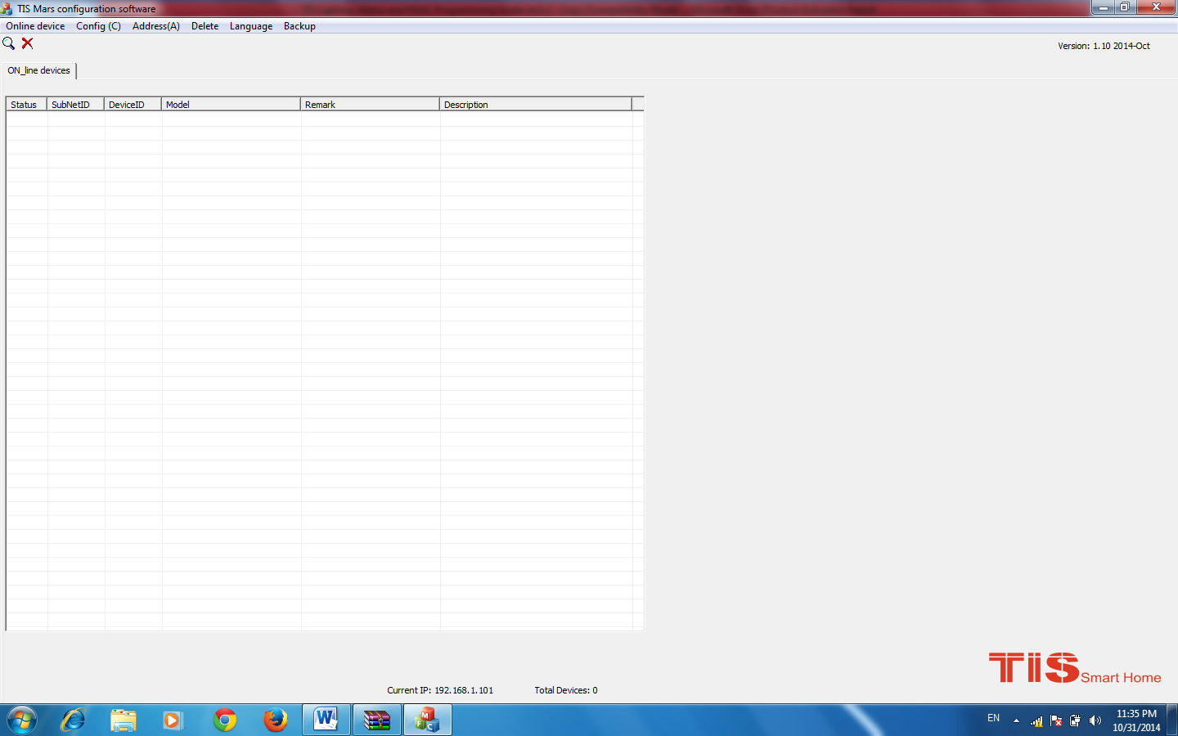
Your local IP address here you will be able to see the total number of devices found
- You can see your current IP on the footer of the software as 192.168.10.101 in the picture then your IP setting is ok.
Set your computer IP setting before starting the TIS-BUS configuration software.
2-2 IP COM Port (programming port)

The Programming Ethernet Port has the following function
- Used as programming port between your computer and the TIS-BUS devices.
- Used as Network bridge for big project network that need more than 64 devices
- Used as a gateway between your system and tablets or mobile phone applications.
- RS232 / RS485 for 3rd party integration.

2-3 Programming Ethernet address and IP Setting

The IP Com Port Default ADDRESS is 192.168.10.100
- Change your computer IP address to 192.169.10.XXX
- Run your TIS-BUS configuration software
- you can change the IP Address from the TIS-BUS Software by searching the devices than double click on IP com Port
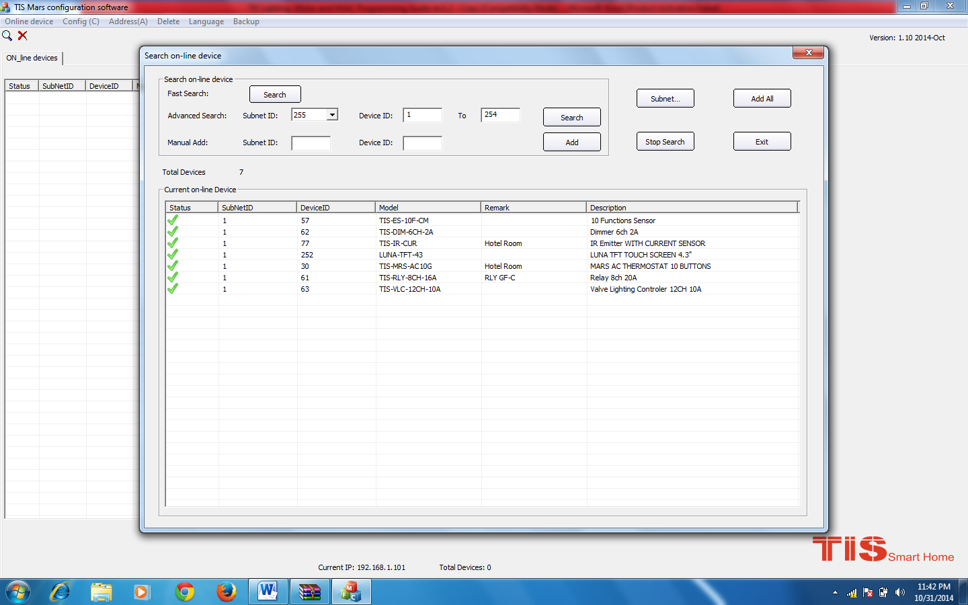

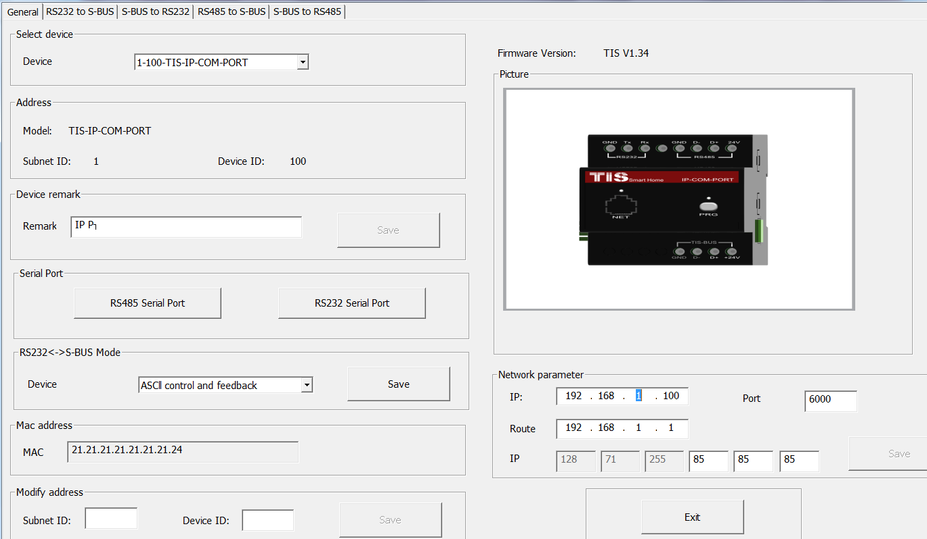

To reset the IP settings of the Module to factory default IP, do the Following
- Power on your module.
- Keep pressing on the PRG button of the module for 10 seconds.
- Your default IP address return to Default 192.168.10.100

It is not recommended to connect more than 64 different devices (such as relay, dimmer, sensors, DMX and other modules) in 1 bus connection without using network bridge.
You can use the Audio player IP as a programming port or as a gateway.

2-4 TIS-BUS Configuration Software basic functions

Online Devices
You can search here for online devices.
Configure
Here you can set your software subnet and device id.
Address
Here you can search for the Device Addresses and load the Network and solve any conflict in the address. (For more Information see 3-2)

Language
You can change the Language between different languages
Data Backup
Important to backup and restore your Devices address and setting, infrared codes.
Developer
This tool is for pro developer of the TIS bus to search and monitoring command or doing advanced level of settings.

2-5 Devices address and Search:
Each of TIS-BUS Devices must have its own Address in the Network, the Address for each Device consist of 2 parts, 1- Subnet ID, 2- Device ID
The subnet ID can be from 0 – 254
And the Device ID can be from 1 – 254
So you can put up to 65024 Deferent Devices in the same project with deferent subnet and device ID Address
For example one of Dimmer Module Address is (Subnet 1, Device ID 5)

There are 5 ways to Search for the Devices in TIS Software
- Fast Search
- Advanced Search
- Manually Search
- Detect Address Device Search
- Solve Conflict address search

Fast Search
The Fast search is very useful tools to test your communication and search your devices fast, the Fast search take around 2-15 seconds to finish load the devices information in your network.
- Press on the Online Search button
- Press on the Fast search Button
- Press add all
- Press Exit to exit the Window
Fast search can’t load all the Network Devices, it is only load part of the devices, it is only good for small project that contain around 10 devices, and to check the network communication with your PC.
Advanced Search
The Advanced Search is a powerful tool for searching your devices in the network. You can set the Subnet ID you like to search on it and select the range of device ID you want to search for.
Advanced search take 0.3 seconds for each device to load and total of 80 seconds to finish the search and load for 255 devices totally in each subnet.
Use the Advanced Search Always as your standard way to Load the Devices in the Network to your computer in any new project.
Manual Search
Manual Search is a very fast and useful way to add known Device ID and subnet to your network
- Type the subnet and device ID that you know
- Press ADD
- Exit the Menu

Broadcast Address Device Search
This tool is important when you add new devices or you start your new Project installation, many devices could have the same Address or the communication is not yet tested, this tool is important to check the communication between your device and the bus network and to change its initial address in the first time installation.

- On your software Press Address/ Manage device Address
- Go to your device like Dimmer / Relay / sensor or Panel and keep pressing the PRG Address button for 6 seconds until the button LED keep ON.
- In your software press on Detect address Button

- Your Device ID and Subnet well appear Automatically
- To change the address just double click on its address and change it
- Press save.
- Press Exit to Close the Window

Solve Conflict address search
This type of search used to solve the conflict address, for example if 2 devices have the same address, then you can easily change the address of it without disconnecting the device from the network
In your software Press Address/ Manage device Address
- Select Subnet 255 (recommended) or any desired subnet then press the search icon
- Press the search button
- Select the device you want to modify its address double click on it
- type the new Subnet ID and Device ID, then Press Save

2-6 Steps of Basic Programming
The Basic Programming procedure for TIS-BUS products are as following.
- Check the communication between your computer and the Bus
- Broadcast each device initial Address
- Change the initial addresses to the desired one
- Give name of each DEVICE
- Check each Lighting channel circuit if working and connected good
- Give name for each channel and type
- Make an excel sheet for all your Dimmers, relays, other module address and circuit name
- Do the same for HVAC , sensors and other devices.
- Start your panel and other devices setting programming…

Follow the basic Programming procedure step by step and it will hep you to save the programmers time and effort.

- Lighting Programming
Relays and Dimmers are the main modules for most of the lighting control and this course will cover its programming procedure

3-1 Relays and Dimmers type overview
TIS-BUS Dimmers and Relay have many types that you can install in any project
- Dimmers
- DIN-Rail Mount Dimmer 2ch 6A
- DIN-Rail Mount Dimmer 4ch 3A
- DIN-Rail Mount Dimmer 6ch 2A
- Wall Mount Dimmer 6CH 10A
- Wall Mount Dimmer 12CH 10A

- Relay ON/OFF controller
- DIN-Rail Mount, Relay Module 4CH, 10A
- DIN-Rail Mount, Relay Module 6CH, 3-5A
- DIN-Rail Mount, Relay Module 8CH, 16-20A
- DIN-Rail Mount, Relay Module 12CH, 10A

3-2 Setting Relay and Dimmers Address
When installing the Dimmer and the Relay for the first time with the factory default device and Subnet ID, to change the device and Subnet ID (this requires only when u have multiple devices of the same type) and the communication press the PRG button to give you the ID’s, also to check the device online you can press the PRG button and detect the IDs as we explain in section 2-5

Line input and neutral connection. 4Channel output to the devices device name, Number of channels and Amps
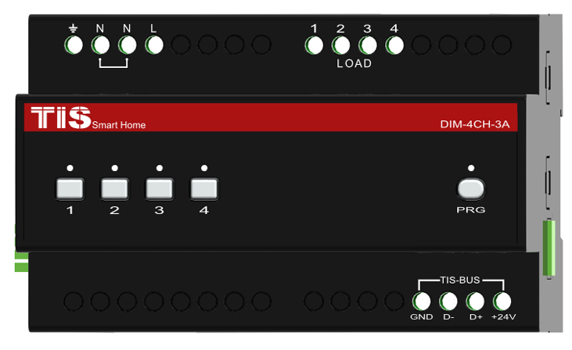
4 channel controls buttons TIS-Bus Connection
3-3 Channels search and Comments
After you finish editing the initial Address for each Dimmer and Relay, Search for all Modules in the network using the Advanced Search and after press Add All Button, after that you can start giving different Name in the comments for each Module.
- Double click on the Module that you see on the List after searching to open it for editing
- In the Comments field type the name of the Module
- Press save after you type the name

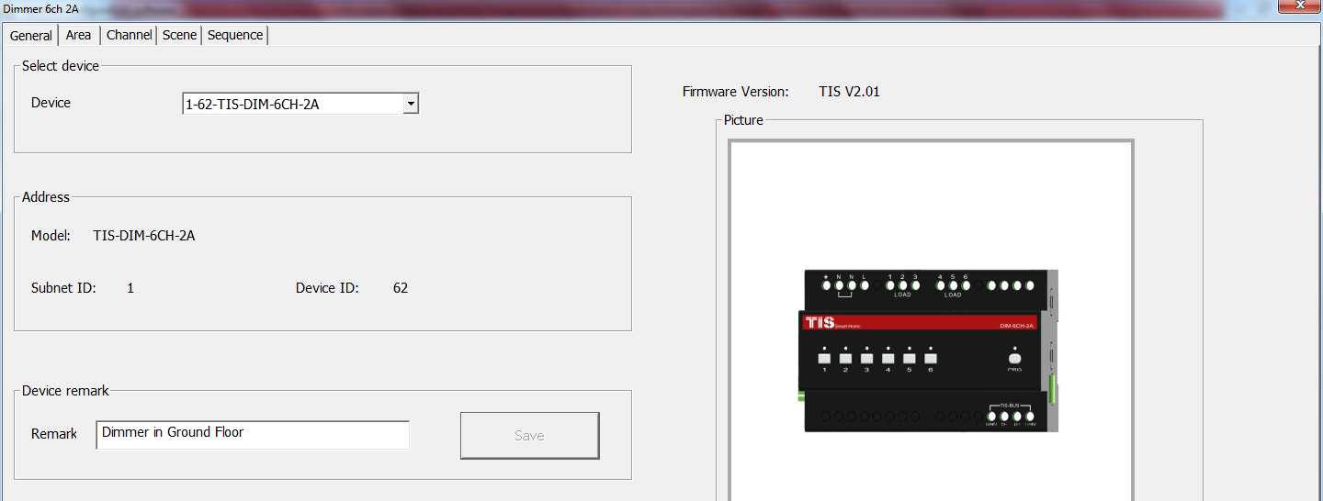
Without giving name to the Dimmers or Relays in your Project, the program will be hard for any programmer to understand, troubleshoot, and enhance the program in the future; name and comments always will help every programmer to do the programming.
Always Give the Dimmers and Relay name that refer to its location, for example if the Dimmer install in the floor 10 Apartment 20 then you can give it name for example DIM-10-20-A the next Dimmer in the same apartment can be DIM-10-20-B and so on and sticker Labeling can be stick on the dimmer module itself with the same name.

Testing Channels online:
After we gave Address and name to the Dimmer and relay, We must test the channel/s and give name to each channel.
- Go to channel setting than press on Load Test
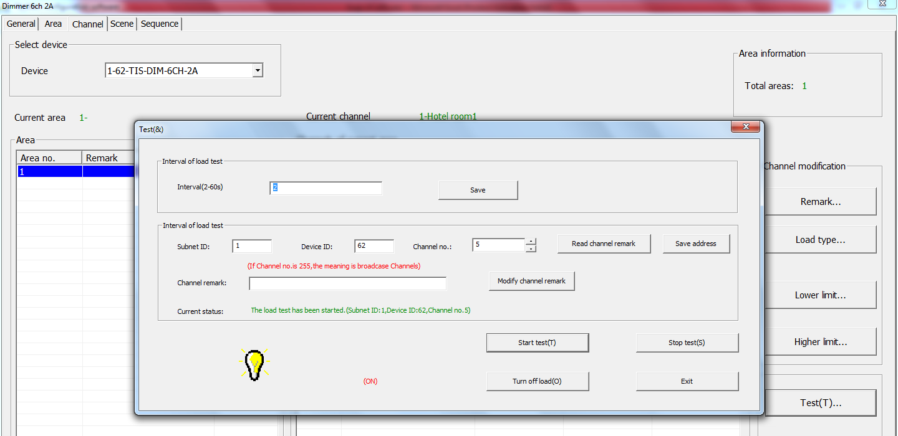
- set the Interval of seconds that will be flash the Light channel ON/OFF within this time (2 seconds is Default) after Editing it Press Save
- Edit the Subnet ID, Device ID of your Dimmer or Relay and Its Light Channel you want to test then press save
- Press start test button, than light icon will start Flashing ON/OFF
- Go to the channel light in your project that connect to this channel and see if the light is flashing or not.
- If the light channel is flashing ON/OFF than your connection is fine, then you can press stop test
- Give the name of this Light channel in the channel comments field then press save
- Go for the next light channel test press save and follow the same steps for each module channels in your project.
Channel Comments are very important for any programming, Programmer should edit all the comments in simple and clear way to refer to the lights Channel name.
3-4 Relay Channels Setting
channel comments in a faster way, If you have the list of your connected channel on your relay before testing it, you can edit each channel information such as remarks, load type, switch on delay (in seconds) and protection ON delay (Minutes).
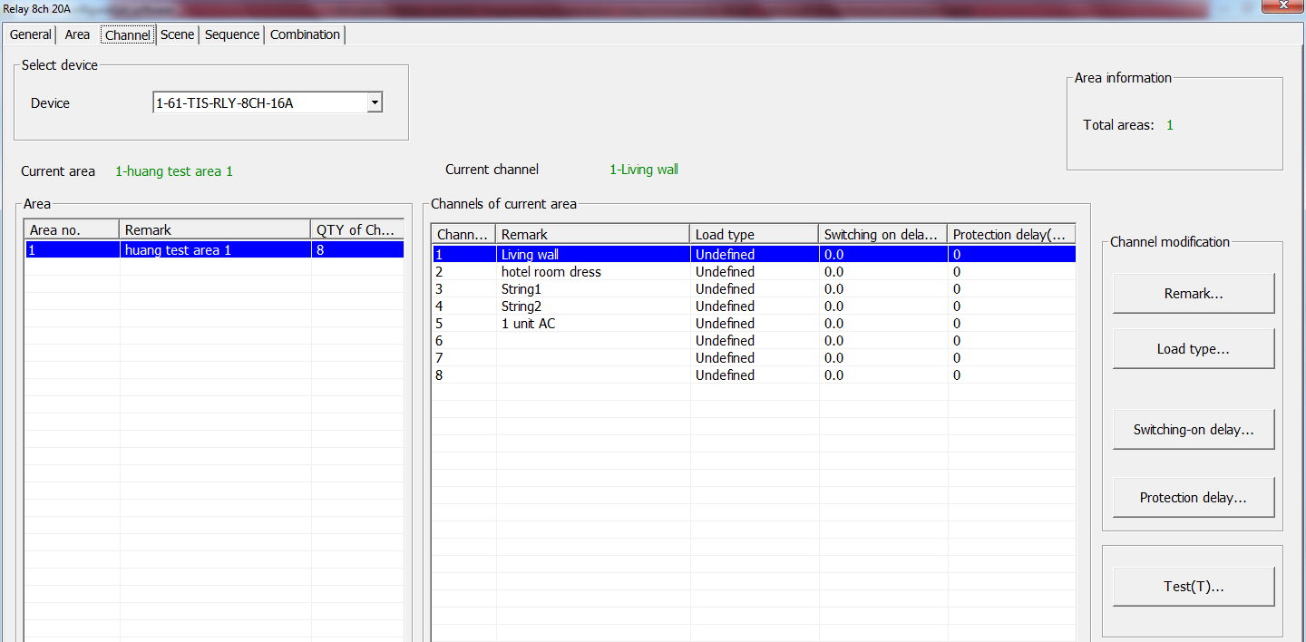
Double click on any relay module listed in your connected devices, the relay setting window will open, click on the channel and you can start editing the information as mention above.
Channel Comments : it is another fast way to type your channels of your module in simple way.
Load type: to edit every channel load type as reference comments
Switching On Delay: for industry and some motors connection needs to delay the Relay to be ON from (0 to 25 seconds) for each channel
Protection Delay: is used for industry use mainly and some heavy duty Machines for safety ON by long time delay range from (0 – 60 Minutes)

3-5 Dimmer Channel Setting
In the Dimmer channel setting you can edit your Dimmer Lighting channel Comments , Load type comments , Lower Limit, Higher Limit.
Double click on any Dimmer Module on the List then the Dimmer setting window will appear go to the Channel tab, and start editing

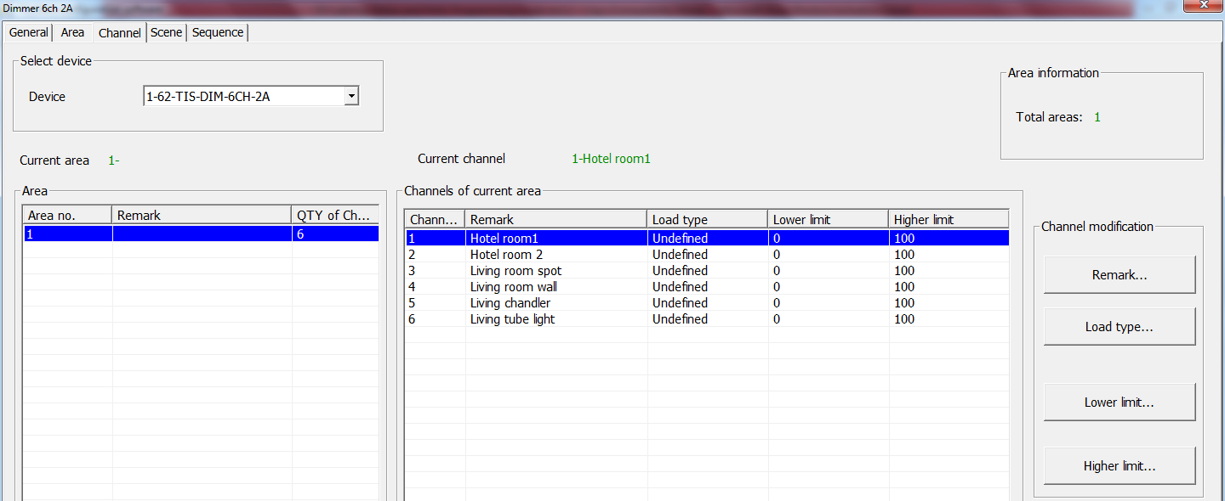
Channel Comments : it is another fast way to type your channels of your module in simple way.
Load type: to edit every channel load type as reference comments
Lower Limit: in this setting you can sit the lower Limit that you can dim to, beyond this level the Light will turn off totally.
Lower Limit Option is useful when you connect a florescent / LED Light that will star flickering below this lower limit because of the low Voltage. Also it is useful for ceiling fan that will start giving noise in low dimming value.

Higher Limit: : is used to set the maximum brightness level for the channel, beyond this level the dimmer can’t give more voltage output

Be careful not to overload the channel, for example if your channel load is 2.7 Amp you cannot connect it to Dimmer of 2 Amp Channel.
Be careful the Load of Dimmer Module of Din-Rail type not to exceed the total maximum box load. See the instruction Manual of each module.

3-6 Area Setting
In the Area setting you will divide your dimmer or Relay channels to different Area according to your project installation, each Area will have its scenes and sequences.
For example: if you have an apartment of 2 bed rooms, all its channels connected to the same dimmer, than you can divide the dimmer channels into 2 area , type name for each area and later you can set the scenes and sequences of each Area separately.
- Double click on any Dimmer or relay on the List
- Got to Area Tab
- Press Area Setup
- By default all channels is included in Area 1, Remove the channel that not belong to this area by checking them and press the Left Arrow.
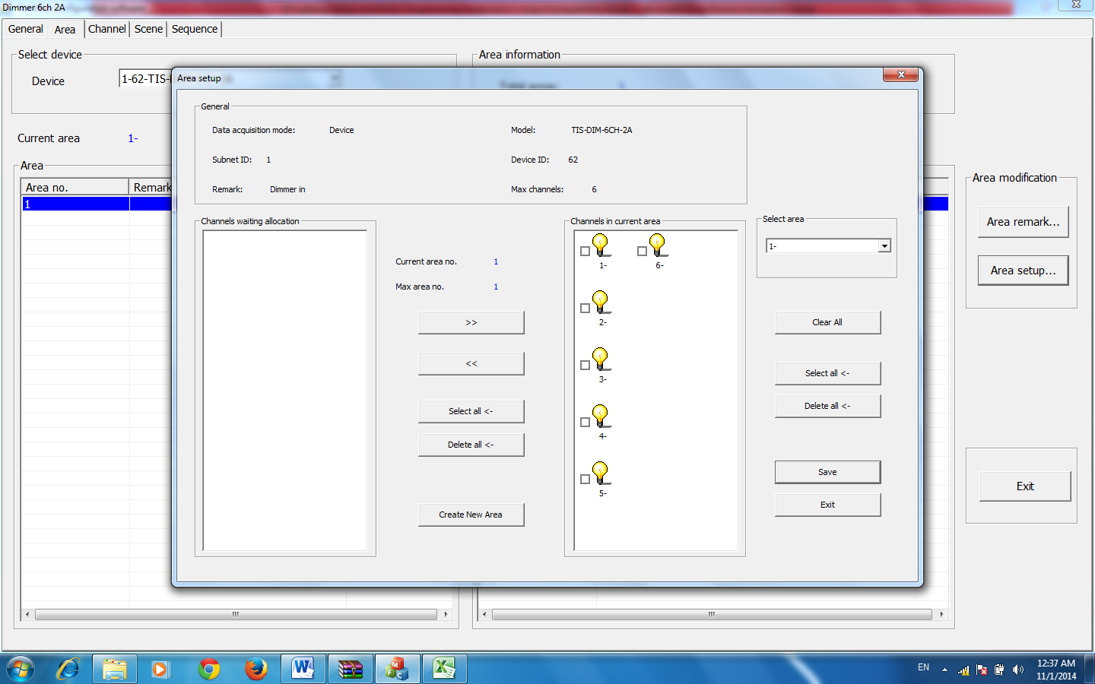
- Press Create Area to Add new Area
- Insert the remaining channels on this Area by pressing the Right Arrow
- When you create all you Area and assign Channels to it, Press Save and Press Exit to close your Area Setting
- Press Area Comments and edit your Area names, then Press Save then Exit.

3-7 Scene Setting
After you complete your Area setting, then you can assign Different Scenes for Each Area you create
- Press on the scene tab
- Select the Area on the select Area section
- Input the scene number you want to edit From … To then press confirm
- Press scene setup to edit your scenes
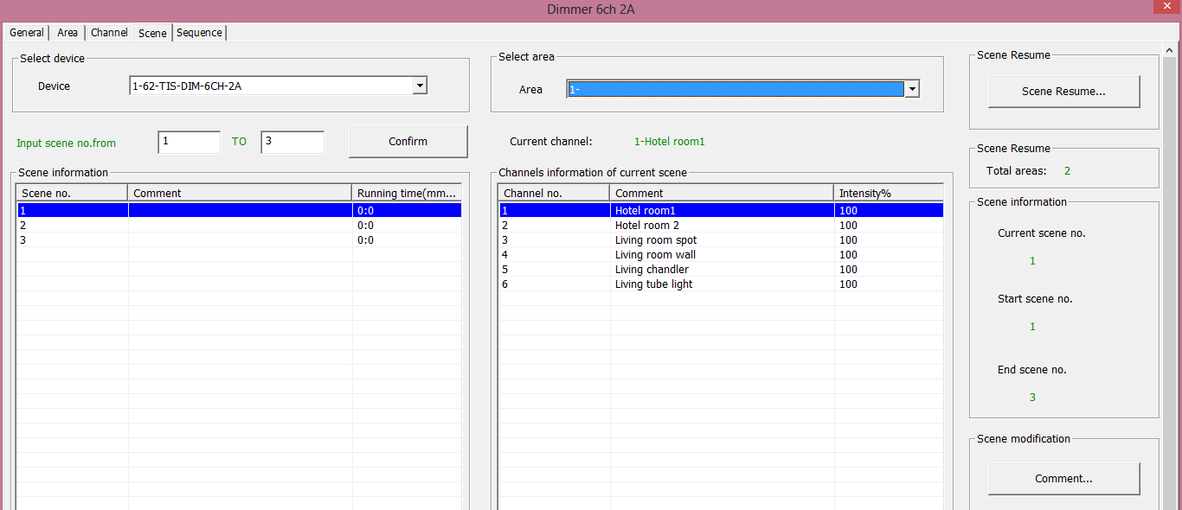
- Edit the scene by modifying the output brightness and then press the next scene on the right list to edit it.
- Edit the scene running fade time on Minutes and seconds
- After you finish editing your scenes, press save and exit.
- Press Comments to give the hint name for your scenes, press save and exit

You have many tools to help you editing the scenes
- Modify Running time Synchronously to apply the change effect for all the scenes running time together
- Modify scene intensity Synchronously, to modify all channels output level together
- On-site Output scene, to see the effect Live on your room before saving the scene.

Creating Area and scenes in the Modules is recommended for faster respond that control many channels in the same command.
Every area has Scene 0 and it is not modifiable, it is Pre-Programmed as scene Off that set all the channels Lights of the area to 0%.

  - Scene Resume
This setting is very important for the dimmer in case of Power failure.
The scene restore is the specified scene that the dimmer module will run it once the Power restore after the electricity failure.
- Press scene tab then press on scene Restore
- Select one of 2 options,
- 1- the scene before power off,
- 2- specific scene Number

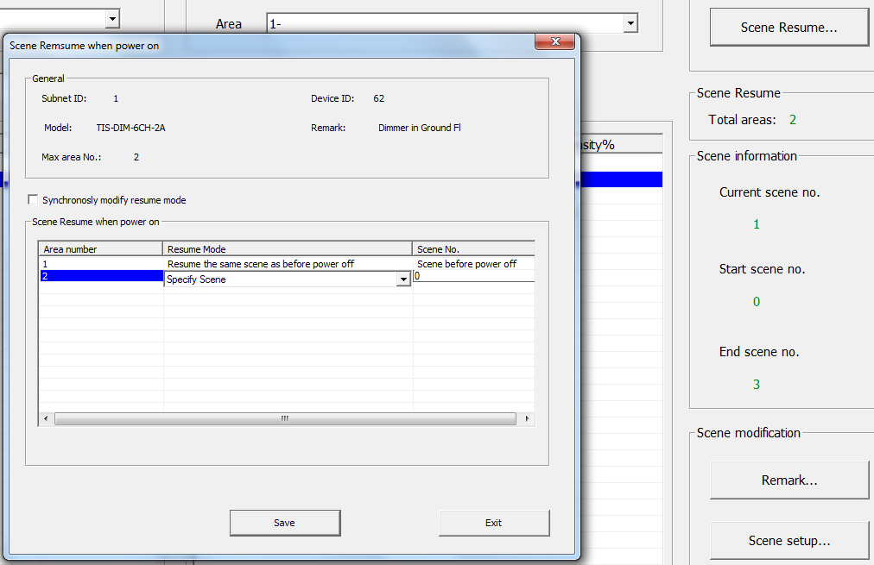
- Remember Scene 0 means all the lights on the Area will be OFF when the Power restores.
Restore to scene 0 is advised to protect the electrical parts of many devices getting damaged if it’s a high voltage when the power comes back.

  - Sequence Setting
Sequence setting is used to make Light Shows mostly through DMX control and for some other industrial applications, security and others.
- Press on the Sequence tap
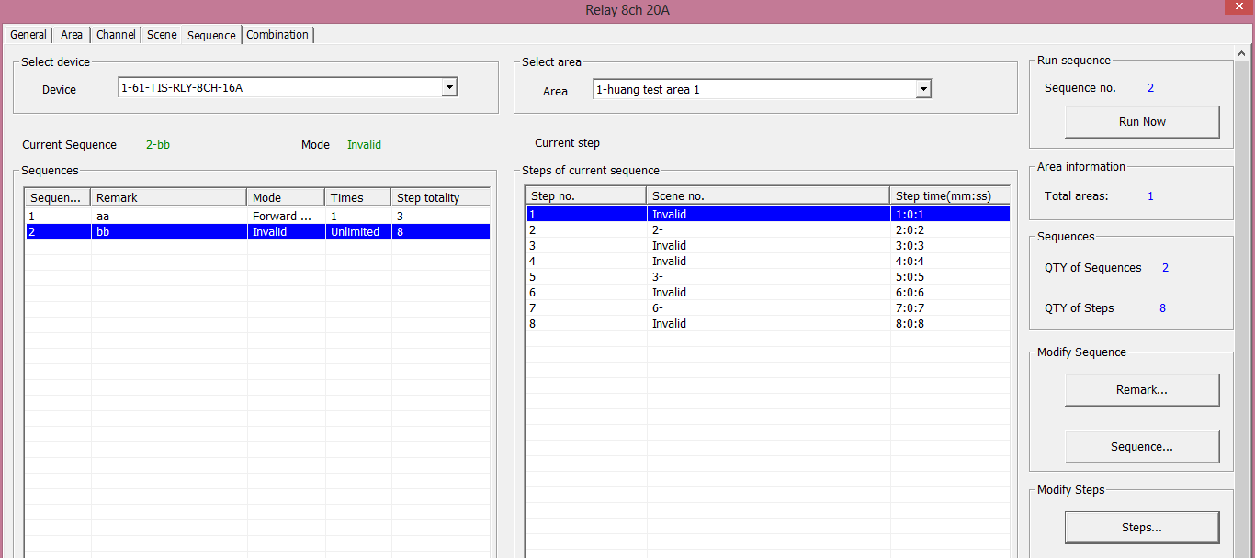
- Press on sequence Button to edit the sequence
- Select the mode you want
Invalid: not used
Random: will run the sequence scenes in random way
Forward, and backward: will run the scenes from first scene to last one then from last to first
Backward: will run the sequence scene from last to first
Forward: will run the sequence scene from first to Last

Times: the sequence can be Unlimited forever running, or will run from 1 time to 99 times.
Step totally: is the sequence scenes steps number that want to be include it in the Sequence
- After you finish editing your sequence setting, Press save and exit.
- Press Comments to edit your Sequence name
- Press Step to edit your sequence steps
- Edit your scene number in each step
- Edit your step time interval on Minutes, seconds, part of seconds
- Press Save and exit

Some Relay Module like RLY-6CH-5A doesn’t have the Sequence
Function and most of modules sequence can run only in 1 area at time.

  - DMX Module Setting
TIS-DMX-48 is 48CH DMX Module to control Stage lighting, TIS Home party lights and DMX LED Driver ..
To program the DMX you need the following steps.
- First you need to set your DMX Devices such as Laser, LED Effects and LED driver address. Refer to each device installation manual.
- Create Areas as per your installed devices and assign its channels in each area. For Example if your laser device address is 1 and it contain of 4 different addresses than you need to assign ch1-4 for area 1.
- Name each area same as device name for example, Laser, Moving head, LED Effect , etc…
- Create scenes for each area.
- Create Sequence for each area.

Most of DMX Devices using the 0-255 method to set its function, to do that you can set the intensity to be 0-255 in the General tab of DMX setting.

Patch and initial DMX all channels address is also important. Most of DMX is initialed by factory default. To change the order of address you can go to channels / patch and change the order of it or to initialize it .
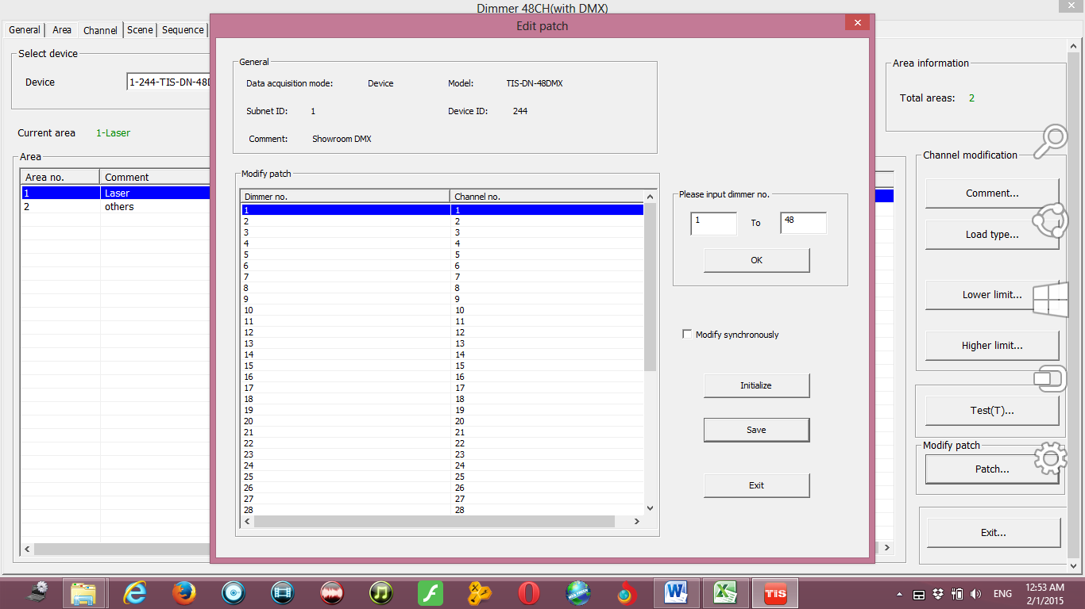
To create Sequence in the DMX go to sequence select an area and press ADD .

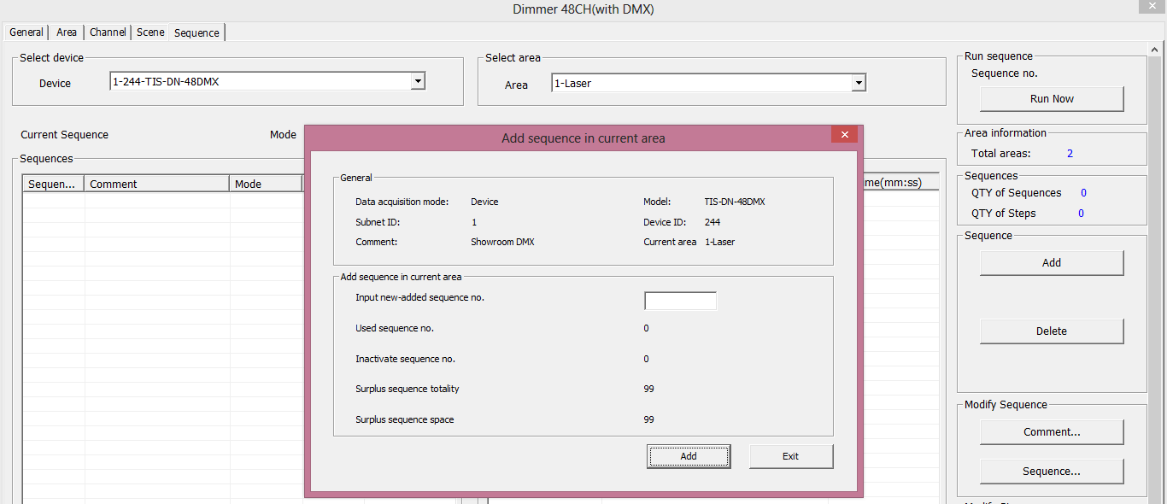
You can add 99 Sequence in total for the DMX48 device so you can manage this between all your area devices by adding and deleting sequence of each area.
After you add steps and time for each step you can test your sequence by pressing on Run now button.

- Curtain and Motor Controller Programming
Motor always need two directional Relays to control it, to protect the damage if both relay work together, usually the changeover relay type is the relay used for the motor control , all TIS relay has the changeover protection to control the motor of any curtain, also TIS BUS motors are available ..

4-1 Curtain and motor controller overview
Beside the TIS-BUS motors that can control most of blinds shutter and curtain types, TIS relay can be linked together as Motor controller that can control any directional motor as open, close and stop status.

4-2 Curtain motor programming
In the relay page go to combination
- Link the 2 channels together by checking the linking box
- See the running time to cut of the power after XX seconds.
Running Time? The time that the motor will be Opening or Closing, after this delay the motor will stop.

Other type of TIS BUS Motor setting is easy, just to put the subnet and device ID of the motor with the location comments, then you can control it from any panel or sensor through the bus network.
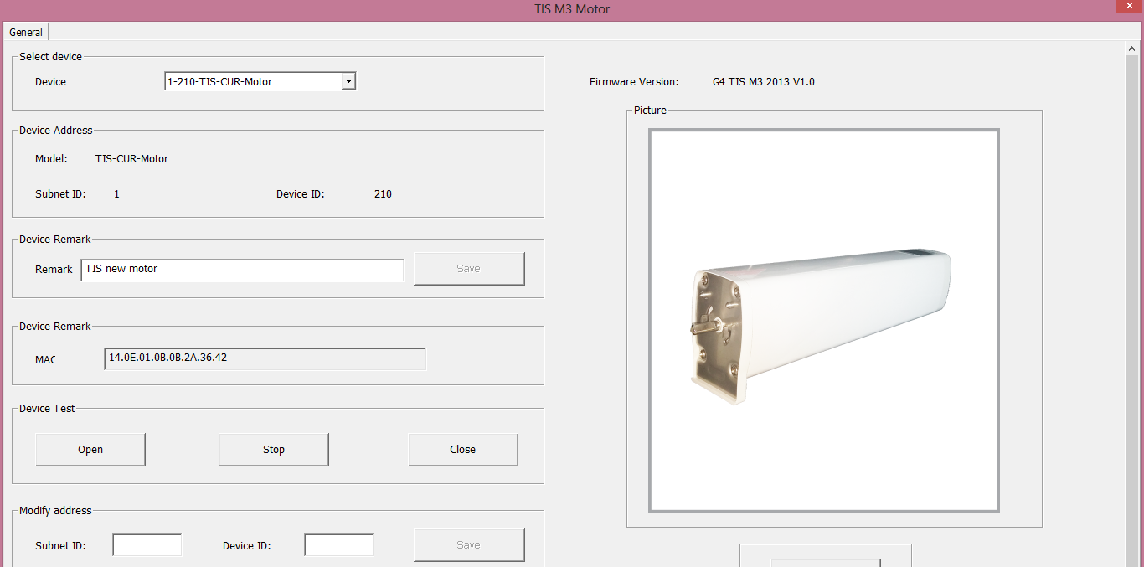

- Panel and Key setting
5-1 Panel basic function
The Switch wall panel is your interface to control your lights, curtain and moods.
The TIS-BUS basic panels have many types, including the Mars 4/8/12 button panel, Luna 9G panel and Terre 6Gangs Panel.
5-2 Panel Switch Address and basic setting
To change the address and check the communication you should use the detect Address Device Search as you see in the section 2-5 before.
Every Switch Panel can broadcast its address by pressing on any button (in Mars or Terre Series, button9 in Luna9G) for more than 8 seconds, it will start flashing and sending its address to the network.

After you load the Panel to the network, double click on it.
- In the basic setting you can type the panel location comments , change its address subnet, and device ID
- Also you can change the backlit brightness and LED indicator method and brightness of the Buttons
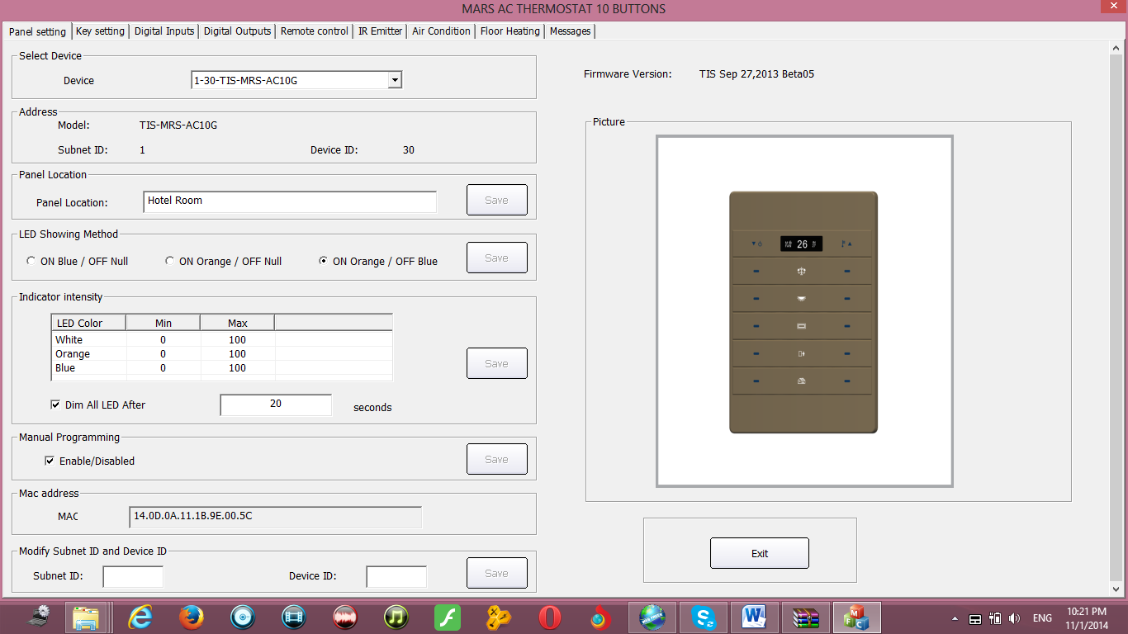

5-3 Panel key settings and Modes
When we go to the Panel setting tab we will see all the buttons listed on the screen, by pressing the mode button we can change the Button function as you can see on this picture
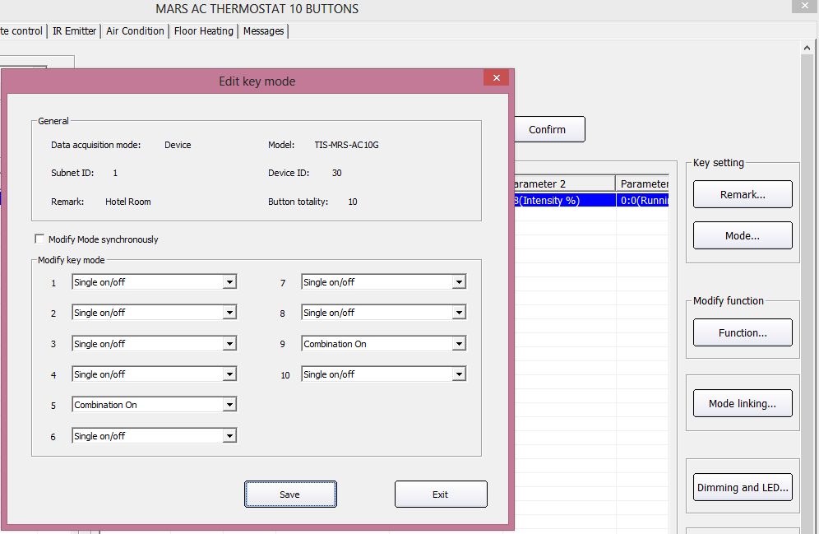

Panel Switch Button Mode Setting
Mode | Function | Where to use example | How to use
Invalid | No function | When you have extra button that you don’t need to use it | No use
Single OFF | To OFF Light or scene, every time you press it | In room off mode to close the Light channel | Single Press
Single ON | To run scene ON , or Lights on every time you press | Usually used to trigger scene like visitor, meeting mode etc.. | Single Pr  ess
Single ON/OFF | The classical use of toggling of single press ON/OFF | Widely use for ON/OFF light , scene by single press | Single Press ON  , Single Press OFF, keep pressing Dim/ keep pressing Ramp
Combination ON | To trigger up to 99 different commands every time the button pressed | to Run complex mode that required more than 1 scene and mode by single press | Single Press
Combination OFF | To OFF up to 99 commands every time the button pressed | To OFF complex mode that required more than 1 scene and mode by single press | Single Press
Combination ON/OFF | To trigger up to 99 commands toggling between ON/OFF each time the button pressed | To run ON and OFF complex mode that required more than 1 scene and mode by single press | Single Press ON commands, Single Press OFF commands
Double click, single switch | To use the double click to run up to 49 commands while single press will toggle between ON/OFF of different commands | Used as extra function to trigger any other scenes on double click of the same button, like Double click can trigger ALL room off | Double fast click on the right button side to trigger double click function, Single Press ON, Single Press OFF, keep pressing Dim/ keep pressing Ramp
Double click, Combination switch | To use the double click to run up to 49 commands while single press will toggle between 50 commands ON/OFF | Used as extra function to trigger any other scenes on double click and different one for single Press | Double fast click on the right button side to trigger double click function, Single Press ON, Single Press OFF
Pressing on releasing off | To run 1 command as momentary pressing | Used for example in Bell, gate motor , some IR commands | Keep pressing to keep sending on command, On release the OFF command will trigger

- To edit Button Comments press Comment edit then Save and Exit

be careful when using Combination mode, the button will not have 2 way feedback status , then the panel LED cannot be updated if the lights channel ON or OFF from other devices.
When using Combination, you will not be able to dim the Light channel or scene.
Try always to use Single ON/OFF, cause its 2 way updated and simple friendly use for the end user.
When you select invalid button the LED of the button will be disabled.

5-4 Panel Switch type command settings
For each button you can make different functions of different type commands
- On the panel window go to key setting
- Press on the Function button
- Press on type popup menu and you can select the function you want as you can see on the picture

- Press Save and Exit.
The Button Function of switch panel you can make is listed down on this table

Function type | Parameter 1 | Parameter 2 | Parameter 3
Invalid | N/A | N/A | N/A
Scene Switch | Area Number | Scene Number | N/A
Sequence Switch | Area Number | Sequence Number | N/A
Universal Switch | Switch Number | ON / OFF | N/A
Single channel Lights | Channel Number | Brightness 0-100% | Fade time  0S - 60 M
Curtain Switch | Switch Number | Stop / ON/ OFF | N/A
Panel control | IR Function | ON / OFF | N/A
Panel control | Panel related command | Parameter 2 | Parameter 3
Panel control | Air condition command | AC temp or speed | N/A
Broadcast scene | All Area | Scene Number | N/A
Broadcast Channel | ALL Channel | Brightness 0-100% | Fade time  0S - 60 M
Security Module | Area No | Arm Mode / Disarm | N/A
Audio Player | Main Command | Sub command | Other setting

Each Function type is necessary for different Action

Example of each one as the table below
Function Type | Example of using
Invalid | Is to disable the function
Scene Switch | Used to trigger the Scene that you create on the Dimmer , relay or DMX Area
Sequence Switch | Used To trigger the Sequence that you create on the Dimmer, relay or DMX Area
Universal Switch | Used to send infrared code number, set logic flag On or Off, set the hotel doorbell services , disable or enable (Motion sensor, light intensity, zone port automation ) , trigger messages / SMS
Single channel Lights | Used to turn one channel lights / curtain or any output on./off with special level and running fade time
Curtain Switch | Used to open, close or stop the curtain channel
Panel control , AC Power | Used to turn the Air condition , ON/OFF
Panel control Cooling Temp | Used to set the Air condition cooling desired temperature to 0-30 C , 32- 86F
Panel control FAN Speed | Used to set the Fan type between Auto, High , Medium , Low
Panel control  AC Mode | Used to set the AC mode to run as Auto, Cooling, Heating , Fan only
Panel control Heating Temp | Used to set the Air condition heating desired temperature to 0-30 C , 32- 86F
Panel control Auto temp | Used to set the Air condition Auto mode desired temperature to 0-30 C , 32- 86F
Panel control  Up temp | Used to Rise the Temperature by 1-5 C
Panel control Down Temp | Used to Lower the Temperature by 1-5 C
Panel control LCD Backlit | Used to set the backlit of LCD ON / OFF
Panel control LCD status light | Used to dim . ON/OFF the LCD brightness of wall LCD panel
Panel control Lock button | Used to lock/unlock any other panel buttons.
Panel control Lock page | Used to lock/unlock any other panel pages.
Panel control , control button status | Can turn on/off the Led status of any other button to enhance the feedback status of buttons
Panel control , control button | It can trigger any programmed button of other panel to safe the programming time.
Panel Control , floor heater power | Can turn the floor heater ON/OFF
Panel control floor heater set point | Can set the temperature of floor heater
Broadcast scene | Used to trigger same scene number for all the Areas of the dimmer or relay
Broadcast Channel | Used to turn ON/OFF or set channel to brightness level for the all channel of Dimmer or relay
Security module | Can arm / disarm area from 1-8 to any mode or trigger the panic or fire alarm commands
Audio Player | Can select the source (SD, FM radio FTP, Aux) select Album play/ stop track, radio channel , and select volume.

When choosing Combination or double click mode you have to input the function target number from … to then press confirm

When using double click / Combination you can change between each function setting in the radio log as the picture below
Double click always will save the commands from 51 to 99, be careful when you change the button mode from double click to Combination mode only then the old setting of commands from 51 to 99 will remain and remain Active.

Try always to refresh the page, to make sure not old wrong setting appears on the page, to refresh the page press right click on the mouse then press on Refresh (Clear buffer memory, reread data from device)

Useful tools for editing your Functions
There are some useful tools to help you while you are making setting for multi functions together like the one in Combination and double click mode
Modify Subnet ID synchronously: to modify all subnet ID together and save the time of editing each one alone
Modify Device ID synchronously: to modify all Device ID together and save the time of editing each one alone
Modify type synchronously: to modify all function type together and save the time of editing each one alone
Modify the intensity synchronously: to modify all Level brightness intensity together and save the time of editing each one alone
Modify the running time synchronously: to modify all the running fade time together and save the time of editing each one alone

5-5 Panel Switch button Memory, Dimming, and LED Setting
Beside the Button mode and function there are three important setting for each button
We can categorize it as:
- Memory / Toggling setting: the memory will save the last Dimming value, every time you switch ON the light channel it will go to the last lights brightness Level you set before switching it OFF, while the toggling will turn the lights brightness to the maximum level and not save the last status.
- Dimming / not Dimming setting: it is simple setting you can use Dimming when your target lights is dimmable, while using not dimmable when your target is not Dimmable Lights.
- LED enable / Disable Setting, you can enable your 2 way Button LED status, while in some situation you need always to disable the button LED.

How to make LED, Dimming, Memory/toggling setting
- Go to key settings tab on the panel setting
- Press on Dimming and LED
- Select the setting for each button you need

5-6 Example about Lighting, Motor shade Programming
The customer has BED ROOM that has the following lights connected to dimmer and relay, with one TIS curtain Motor and mars 8 Gangs panel
Channel name | Channel type | Module type and Address
Center spot light | Dimmable Light | Dimmer Sub 1, Device ID 11 , Ch 1
Wall Lights | Dimmable Light | Dimmer Sub 1, Device ID 11 , Ch 3
Chandler | Dimmable Light | Dimmer Sub 1, Device ID 11 , Ch 4
Florescent Light | Not dimmable | Relay Sub 1, Device ID 12 , Ch 1
Cove robe Light | Not dimmable | Relay Sub 1, Device ID 12 , Ch 2
Curtain | Curtain motor | Motor control Sub 1, Device ID 15
8 button Panel | Wall panel | Mars8G panel, Sub 1, Device ID 1

The client wants the programming of his panel to be as the following
Button No | Function
Button 1 | He want it to be as the following: single press to switch ON the center spot light, and single press to switch off the center spot lights, he want to be able to dim and ramp the lights by keep pressing the button , and he want the button to save the brightness level every time he press the lights On. And he want the LED status to update him about the lights channel status
Button 2 | He want it to be as the following: single press to switch ON the florescent light, and single press to switch off the florescent lights, this channel is not dimmable lights so he don’t want the dimmable function , And he want the LED status to update him about the lights channel status
Button 3 | He want to trigger a scene to run the reading mode every time he press the button, the scene will be as (make the Center spot light to be 60%, Wall Lights to be 80, Chandler to be 40%, Florescent Light to be ON, Cove Lights to be OFF, and the shade will be open)
Button 4 | He want to run the Movie Mode every time he press, the scene will be as following (make the Center spot light to be 20%, Wall Lights to be 30, Chandler to be OFF 0%, Florescent Light to be OFF, Cove Lights to be OFF, and the shade will be close)
Button 5 | He want to run the saving energy mode, the mode will not affect the Wall lights but will turn the Center spot light to be 0%, Wall Lights to be 0, Chandler to be OFF 0%, Florescent Light to be OFF, Cove Lights to be OFF and the shade will be close
Button 6 | He want it to be as single press to run the sleep mode, double click to run all room off, in the sleep mode , all the dimmable lights in the room will turn off slowly by 1 minute running fade time while the not dimmable lights will turn off fast and the curtain will close, while on double click all the lights will off fast directly and curtain will open, the customer don’t want LED status to indicate while he is on sleep or All OFF mode

Try to make the above requirement yourself before looking to the instruction steps

To program the above requirement Please do the following steps and then test your program, after you finish this example you will be able to do anything regarding the lighting and motor control programming.

- Go to your Dimmer setting , and specify Area 1 to include (ch1, ch3, ch4) and remove from the area 1 all the other extra Channels
- Put the comments of area 1 as bed room
- Go to scene setting and select area 1 and specify from 1- 3 scene then press confirm and star make your scenes as, scene 1 , (Reading mode) set the channel level as required and set the running time as 0 seconds, scene 2 Movie mode set the channel level as required and set the running time as 0 seconds, set scene 3 sleep mode, set all channel to be OFF and set the running time as 1 Minute.
- type the scenes names as 1 reading mode, 2 movie mode, 3 sleeping mode
- in the same way, go to the relay and set the Relay Area 1 to include ch1, ch2 and remove all the other extra channels from area 1
- Type the area name
- Set the area scenes , select area 1 and set 1 scene of reading mode and set the required and set the running time as 0 seconds
- Type the name of the scene
- Go to the curtain and type the channel comments
- Set the running time, ON/OFF delay depend on your curtain motor needs
- Go to your 6 button switch panel setting and type the panel comments name
- Set button 1 mode as Single ON/OFF
- Set Button 1 Function type as single channel lights,(subnet 1, Device ID 11 channel 1, Level 100%, running time 0:0

- Set the button function as Dimming, LED enable, Memory,
- you can test your programming for the first button, by single press ON – Single Press OFF, Keep Press Ramp/DIM, Keep Press again Ramp/DIM, if everything working fine then your first button programming is done
- Set button 2 mode as Single ON/OFF
- Set Button 2 Function type as single channel lights,(subnet 1, Device ID 12 channel 1, Level 100%, running time 0:0
- Set the button function as no Dimming, LED enable, toggle,
- you can test your programming for the second button, by single press ON, Single Press OFF, keep press will Toggle the light on release if everything working fine then your second button programming is done
- Set button 3 mode as Combination ON
- Set target function from 1-3, and set first function type as (scene switch, subnet 1, Device ID 11 area 1, scene 1), set second function as (scene switch, subnet 1, Device ID 12 area 1, scene 1),set third function as (curtain control subnet 1, Device ID 15, and set channel 1 to be ON）
- you can test your programming for the third button, by single press to trigger all your needs as reading mode, if everything running correct meaning your button programming done
- Set button 4 mode as Combination ON
- Set target function from 1-3, and set first function type as (scene switch, subnet 1, Device ID 11 area 1, scene 2), set second function as (scene switch, subnet 1, Device ID 12 area 1, scene 0),set third function as curtain control and set subnet 1 , device ID 15 channel 2 to be ON
- you can test your programming for the forth button, by single press to trigger all your needs as movie mode , if everything running correct meaning your button programming done
- Set button 5 mode as Combination ON
- Set target function from 1-4, and set first function type as (single channel light switch, subnet 1, Device ID 11 channel 1, level 0%, running 0:0), set second function type as (single channel light switch, subnet 1, Device ID 11 channel 4, level 0%, running 0:0),set third function as (scene switch, subnet 1, Device ID 12 area 1, scene 0),set forth function as (
curtain control subnet 1, Device ID 15, and set channel 2 to be ON)
- you can test your programming for the fifth button, by single press to trigger all your needs as saving energy mode , if everything running correct meaning your button programming done
- Set button6 mode as Double click/ Combination
- Put the selection for functions target on Switch to configure the sleep mode function see the picture below
- Set target function from 1-3 and press confirm, then set first function type as (scene switch, subnet 1, Device ID 11 area 1, scene 3), set the second function as (scene switch, subnet 1, Device ID 12 area 1, scene 0),set third function as (curtain control subnet 1, Device ID 15, and set channel 2 to be ON)
- you can test your programming for the fifth button, by single
- Put the selection for functions target on double click function
- Set target function from 1-3, and press confirm, then set first function type as (scene switch, subnet 1, Device ID 11 area 1, scene 0), set the second function as (scene switch, subnet 1, Device ID 12 area 1, scene 0),set third function as (curtain control subnet 1, Device ID 15, and set channel 1 to be ON)
- Set your button LED as Invalid
- Single press to trigger all your needs as sleep mode , then double click on the right side to trigger all off mode , if everything running correct meaning your button programming done

After you complete this example, try to use different button mode that you don’t use on the above example like (pressing on release off, single ON, Single OFF, Double click/Single, combinations OFF), also try to use some functions like (Sequence). And change in the buttons settings like (Dimming LED and memory), toggling function to understand the function very well.

Mode linking Function
This function is used on switch panel to link between two or more combination ON/OFF button mode to consider them as 1 group, and to prevent the confusion of using two related macros together.
- On the key setting press on the mode linking button
- Set the value to YES for all the buttons of combination ON/OFF to be as 1 group together

Try to make two buttons as combination ON/OFF with many commands and set them mode linking to YES and recognize the difference

5-7 Panel Switch Setup (Minimum Dimming Value and Infrared)
Minimum Dimming value: is used to force the panel not to dim the light from the button by keep pressing it in order not to go below the minimum level of dimming
Infrared function: is used to enable or disable the IR receiving function on the panel,
To make the setting of the of the Minimum Level and IR setting
- Go to Key settings tab
- Press IR and others button
- Adjust the Minimum Dimming Value from 0% - 50%
- Uncheck the Infrared receiving function to disable or check the box to enable it

Minimum level is very important and useful function to avoid the confusion for the user when he dim some memory button to 10% and the spot lights will appear as OFF while it is 10% dimming, when the user press the button single press it will toggle between 10% and 0% and the user will think the lights is burned cause he will not notice the 10%.
Minimum level recommended being as 25% so the lights will not go below this level when the user keeps pressing the button.
IR disabling is useful when 2 panel near each other in 1 room and the remote control sending to the both panel and the functions is confusing the user, disabling 1 panel IR is recommended on this situation.

  - Remote control function
All Mars and Luna panel came with internal and external IR receiver that work with TIS Remote control TIS-MRC , in the remote control section you can set any button commands you like, also you can set the audio player address so your audio player can play your tracks
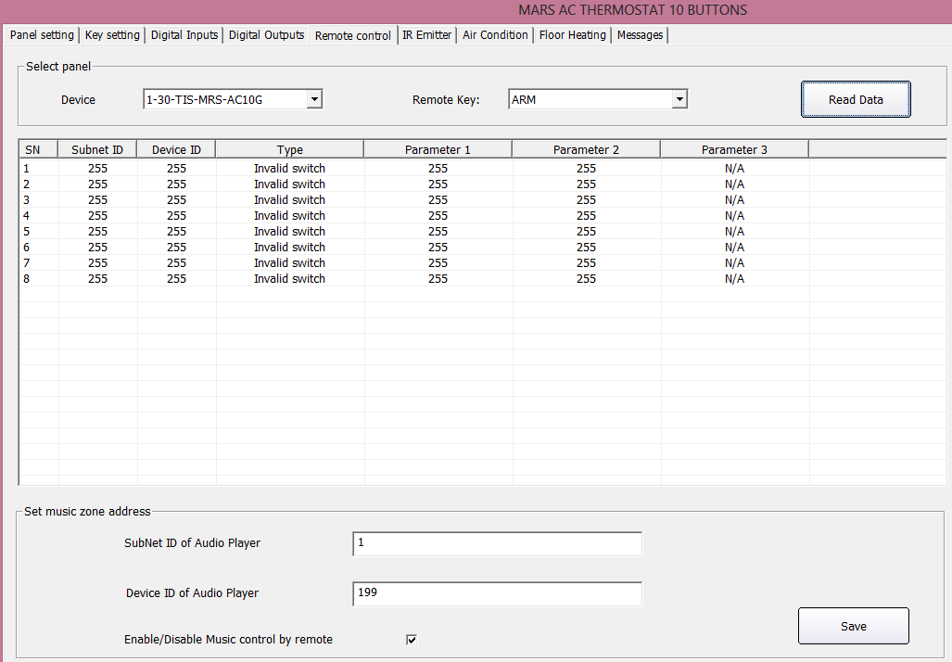

To Try ARM and Panic button you need to press it for 3 seconds on the remote.

5-9 LCD Basic setting

Double click on the Panel on the search List
You can type the Name of the Panel Location in the Comments
In the LCD Backlit you can
- Adjust the Backlit of the LCD from 0-100%
- Adjust the LED status Brightness from 0-100%
- Change panel background colour.
Also from basic setting you can Change the subnet and device ID of the Panel
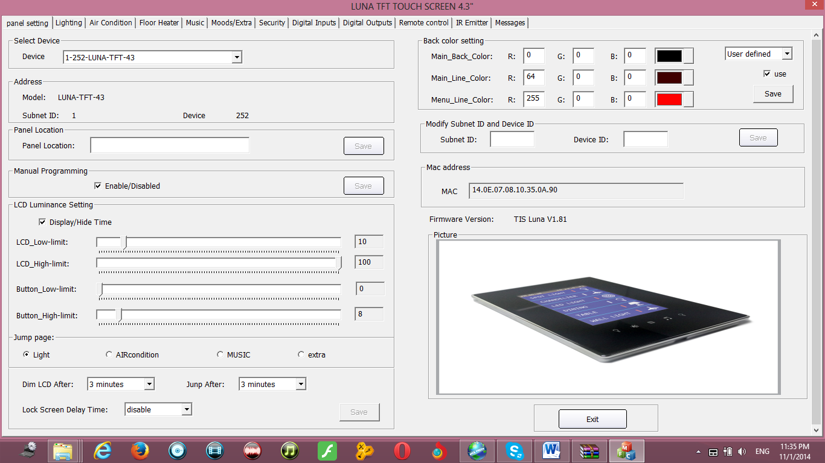

In this page also you can set the brightness setting
It is recommended always to set the backlit to 0-10% after time in all bed rooms so the backlit will not disturb the user while he is sleeping

Page jump setting
- You can set the page to jump to lighting, Ac music or extra pages after a specific time.
It is recommended always to put the Jumping page to Default lighting page, cause the user will use his lighting mostly in his room more than Air-condition or music or other function

Always disable the page that you don’t need in your panel to make your Pages more friendly use and save time to navigate between the needed pages only.

5-10 LCD Lighting/ Extra Pages Button Comments and Modes

Go to Key setting or Moods/Extra tab on the LCD Panel setting
You have total 3 lighting and 2 Moods Extra pages in you Luna LCD Panel you can configure it according to your needs, to move between pages use the Arrows as shown on this Picture

Luna Lighting and mood Picture setting
You can select any Picture from Luna library for both normal Status and ON status
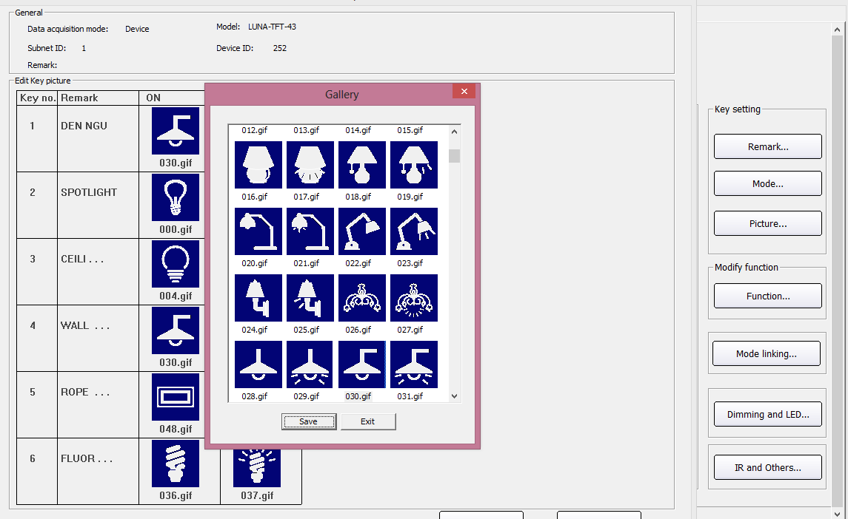
To select the Picture
- In the key setting tab select the page you want to download the picture to it from 1-3
- Press on Picture…
- Double click on the picture you want to change
- New window will open, select your picture than press save than Exit

- HVAC / FCU Programming
HVAC module is the main module that control most of central air condition types, like AHU, FCU, VAV

6-1 Introduction of HVAC Module
The HVAC module have 3 Mode relay type (cool, Heat, and Auxiliary) for the Auxiliary you can configure it as your requirement as (Cool, heat, humidifier, dehumidifier) HVAC Module also include 3 FAN speed relays as slow Med and high speed, with VAV control DC 0-10 V for 3 fan speed Damper..

6-2 HVAC Address and Testing
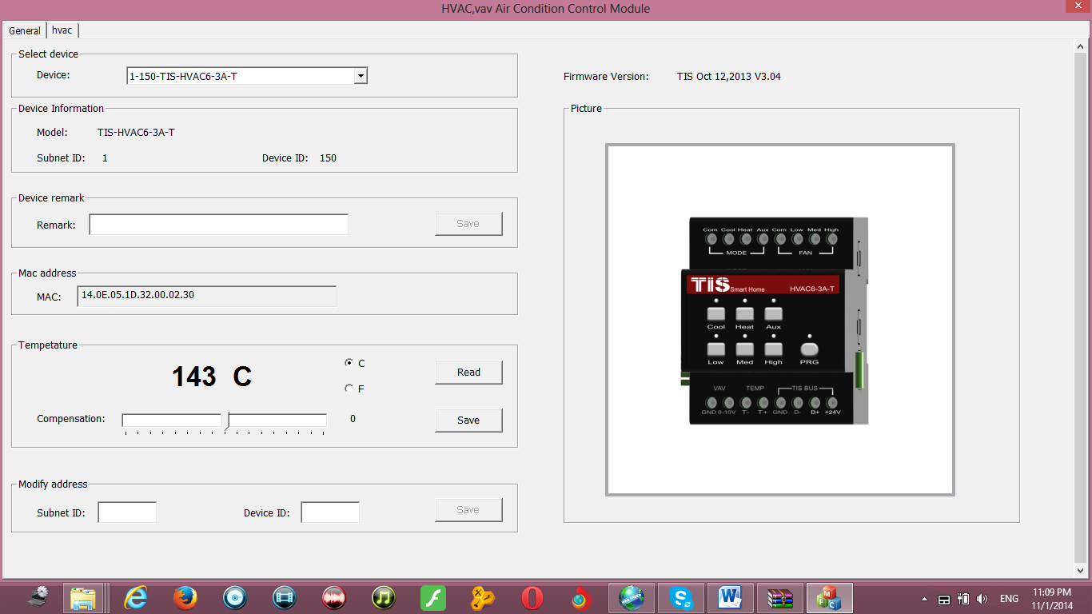
It is recommended to give the name of the room or place that the HVAC is installed or running its AC, for example you can type the comments of the HVAC as Living AC
After you give the Address and comments name for your HVAC module, it is the time to start checking the connection of the module to the unit.

Before you test the AC Mode cooling heating Modes or 0-10V output, you should configure the AC Mode and VAV setting (see 6-4, 6-5)

6-3 HVAC Startup and Switch off Safety Delay
Compressor Startup safety Delay is one of the most important settings you should be aware to set it..
The compressor delay will prevent the HVAC Module to turn the compressor ON directly after it Turned off , Delay time of minutes or seconds always preventing the Direct ON after OFF operation, that will keep your central unite safe, without damaging your compressors and unites.
To do the AC delay setting
- On the HVAC page go to setting
- Go to Air condition delay section
- Set the delay of mode startup, select (seconds 3-600), this setting will prevent the compressor to ON after OFF by this delay Minutes / seconds.
Compressor startup delay is the most important safety setting to protect your AC unit
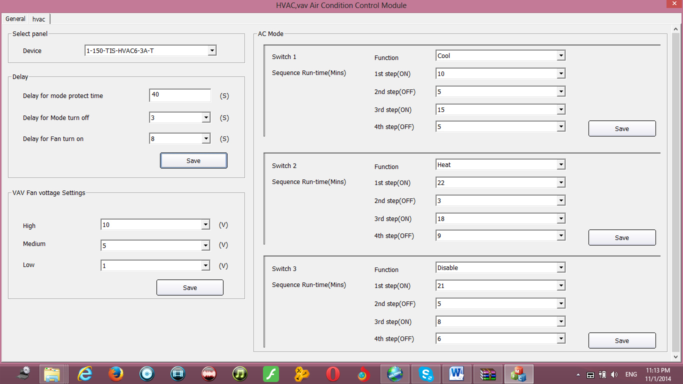

Beside the compressor startup delay there is other function you can set in the Air condition delay section as following
Delay of mode turning off : every time you switch your AC unite, the HVAC will give 0-10 seconds delay time to off your compressor.
Delay of Fan turning on: every time you start your Fan, the HVAC will give 0-10 seconds delay time to start your Fan.

Always Read the AC unit instruction and installation manuals before any installation or programming to fit the best requirement for your AC control
6-4 HVAC Mode Configuration and safety Running Sequence
In this setting you will configure the HVAC Mode compressor

In the switch 3 configuration you can set the function mode for each relay switch, this module support single stage and multi stage Unites, for example if you have a big unit of 2 cool compressors , then you can set the as cool.
The table below shows you the setting and function table of your HVAC mode configuration

Setting | Usage of this Function
Function Cool | Used to configure the relay switch that will be connecting to the central AC unit cooling compressor wire
Function Heat | Used to configure the relay switch that will be connecting to the central AC unit Heating compressor wire
Function Auxiliary | Used to configure the relay switch that will be connecting to the Humidifier, dehumidifier, fresh air motor wires, FAN
Function Disable | To Disable the Relay switch , it is used when there is no connection to the relay, and it is important to disable it to save the unnecessary consumption
Sequence Running time 1st step ON, 2nd step OFF | Used for safety startup sequence to rest the compressor after couple of minutes of starting by 2nd step OFF minutes
Sequence Running time 3rd step ON, 4th step OFF | Used for safety running sequence to rest the compressor after couple of minutes of running by 4th step OFF minutes especially in case of multi stage compressor to let one rest while the other is starting and vice versa

Example of double stage cooling unit safety running sequence setting
This setting will let the both compressor to run as startup sequence together for 20 minutes (1st , 2nd steps) while in the running time (3rd, 4th steps) , each compressor will (start and stop) in different times to rest and save the consumption of AC

Switch 1  Cool | Function | Cool
 | 1st step ON | 20
 | 2nd step OFF | 0
 | 3rd step ON | 9
 | 4th step OFF | 3
Switch 3  Cool | Function | Cool
 | 1st step ON | 20
 | 2nd step OFF | 5
 | 3rd step ON | 12
 | 4th step OFF | 4

Value 0 Minute will disable the step in the safety sequence settings

Safety running sequence is important to keep and extend the life of your central AC unit.

6-5 HVAC VAV Fan Voltage Output Setting
VAV setting is to set the Variable DC Voltage output for each fan speed from 0-10 VDC
- Go to Setting on the AC page
- Go to VAV fan voltage setting
- Set the Value of Voltage you want to give in each Fan speed Mode

Some VAV unit use 0-5 V, also you can modify your HVAC module VAV voltage setting to adapt with 0-5 V, for example you can set it as (Low 1V, Medium 3V, high 5V).

This HVAC Module work and communicate with the Mars AC10G and Luna LCD Panel please read section 7-12.

6-6 FCU Fan speed low med high using relay 6 and 12 CH
You can link 3 Channels of the relay and use it as Low med and high fan speed controller
Go to relay / combination setting and set your 3 relays to be linked together
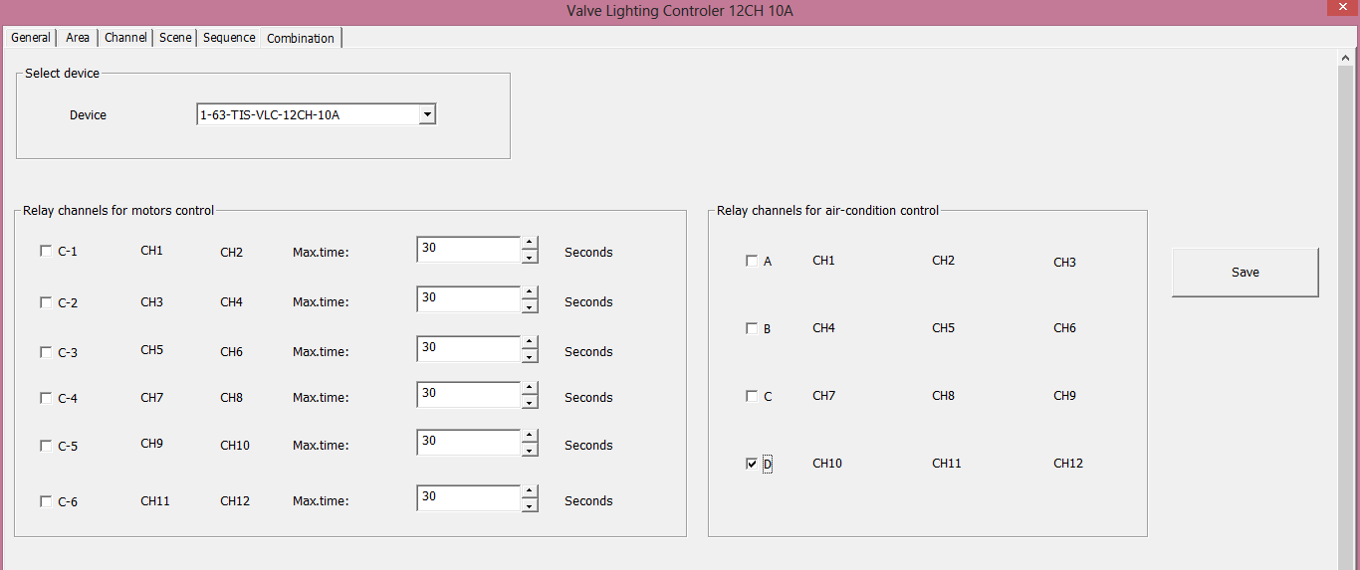
Than later on you can assign this FCU with MARS / Luna Panel to control the Air condition.

- TIS LCD Panels (LCD and Air condition control)
In this lesson we will learn about some of the function of the LCD panel that will cover the Lighting, scenes, curtain and air condition setting.

7-1 Panels with Thermostat and Air condition control
This panels can control air-condition With Thermostat or by Infrared.
Luna TFT, has multi lighting control pages with 2 AC master pages, floor heater page and 2 slave AC pages, music page, A/V page, security page, and 2 moods extra page with settings pages.
Also Mars AC10G, LUNA-BEDSIDE- and TERRE AC thermostat all has AC and floor heater control.

7-2 Luna and Mars AC10G Address Page
The Luna panel Address setting can be set by TIS-BUS configuration software, or manually from the panel itself

To set the Address manually, please do the following:
- On your Luna panel Keep pressing on the Middle square button under the LCD for 6 seconds
- Setting page will appear go to panel address and change it
Changing the Address manually is more convenience and faster for programmer to assign the panels by its address in any new project

For Mars AC10G keep press on the AC Power page for 15 seconds until you see the panel address setting..

7-3 LCD Panel Air condition Basic Setting
Go to Air condition tab, you can in this page enable or disable the AC function of the LCD panel, and make all the other AC setting
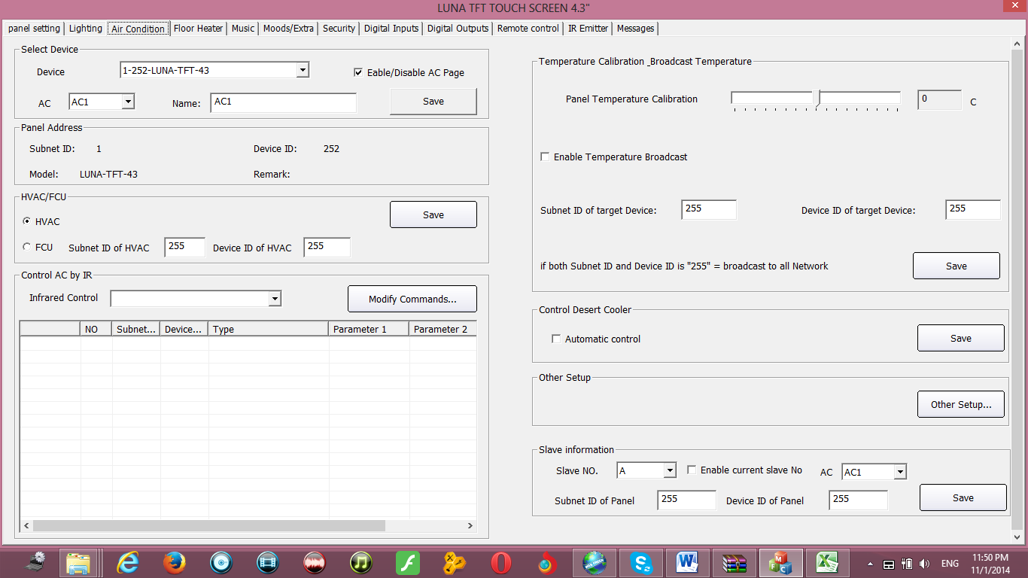

In the Air condition tab you can select AC1 or AC2 than edit the Subnet and device ID for the relative HVAC or FCU ,
For Example if your HVAC Module address is subnet 1 , device ID 33 then type that in the Air condition panel setting and save

7-4 AC Setting Page control Setup

On the Air condition tab press Setup button

In the temperature model you can change the function and display settings
Temperature Type: can be (C) centigrade or (F) Fahrenheit
AC control information: you can enable or disable the options of Fan speed like High low Medium, and Mode type like cooling, fan, heating, and Auto, to disable it to appear as option on the LCD panel
Turn off fan if no cooling or heating: if enable then the Fan will stop with the compressor when the room temperature become equal or below the desired temperature when FAN mode on Auto.
Power ON Option: if the power rest of panel it will turn off the AC or will go back to its last status.
Temperature range you can set your higher and lower set point for each mode (cool, heat, Auto) so the user cannot go above the higher limit, or below the lower limit.

It is recommended always to set the Limit for Cooling , heating and auto, so the user will not make the desired to freezing or very hot level for each mode and to prevent children to do so.
Sensor Mode setting: to refer to the Indoor temp sensor (Panel temp sensor), outside sensor (HVAC or 10F temp sensor). Or Average between both sensors

7-5 LCD Panel Temp Calibration
You can Calibrate your Panel temp sensor to give you exact room temperature, for example: sometimes the Panel installed near heat or cold source , then you have to adjust the temp sensor level to be as the reasonable room temperature where the people set or sleep
To do that
- Go to Adjust Panel temp sensor, you can adjust it (-8 to +8 degree)
- Press save

7-6 LCD AC Slave to other AC Panel
One of the unique functions of the Luna panel is that it can control 2 other AC of other panel.
To set the AC Panel slave on the Air condition tab
- go to slave information section
- select Slave NO from 1-2
- type the slave other Panel Subnet , and Device ID no
- check Enable
- Press save

7-7 Panel Temperature Broadcast Function
This function is important to update the others Devices in the network about the current room temperature
It is useful for Automation and BMS system

Setting broadcast temp to subnet 255, device ID 255 will update all the devices in the Network

7-8 AC Infrared Function overviews.
Also you can use the AC Page to send different Infrared command to control your split AC,

for more information see Infrared control section .

Floor heater setting
You can also control the ON/OFF water valve to control the temperature of room using floor heater control
You can set the setting temperature range and the address of the relay channel subnet device id of the relay in the control object of floor heater parameter setting.

- Digital Inputs
8-1 TIS-BUS Digital Inputs Overview
TIS bus has Different type of Digital module as standalone like 4Z-IN or as a panel addition behind the Mars/Luna panels such as ADD-2DL-IRR or ADD-3DL-12V or in other devices…

8-2 Digital Inputs setting and comments
For each Digital input in Mechanical switch type there is 2 status ON/OFF .
The ON it mean when the digital input is closed circuit, OFF for Open circuit
You can program any input with the commands you like as single channel lights, curtain, AC or music commands by pressing on commands button.
You can set the comments of each input by pressing on comments button.

8-3 Reversing Control Command
The reversing control command is very important for 2 way lighting control if you connect the digital input to normal wall light switches. so it will reverse the status of lighting once you press (connect or disconnect) the wall switch.
To do that set both ON and OFF Mechanical switch to send the same channel light as the following example

8-4 Digital input Delay Time
Each digital input has 2 delay times, one for its on status and one for its off status.
Delay input is important to used for window contact for saving energy and for automation control.
To set the delay time press on delay button and edit the delay by minutes and seconds for each input status, than press Save button.

8-5 enabling/ Disabling Digital input
You can Enable or disable any digital input from the software by pressing the enable button and checking the bix of each digital input to enable it. Uncheck the box for disabling the input.

Please note that you can enable/disable the digial inputs of the device by sending a universal switch command Parametr1 (251 for Input1, 252 for Input2 , . 254 for Input4), parameter2 ON for enable / Off for disable.

9- Ceiling Motion Sensor PIR Programming

9-1 TIS-BUS sensor Overview
TIS bus has simple motion sensor for ceiling type, this motion sensor is used for automation and saving energy.

9-2 PIR Motion sensor Basic setting
Double click on the motion sensor on the List
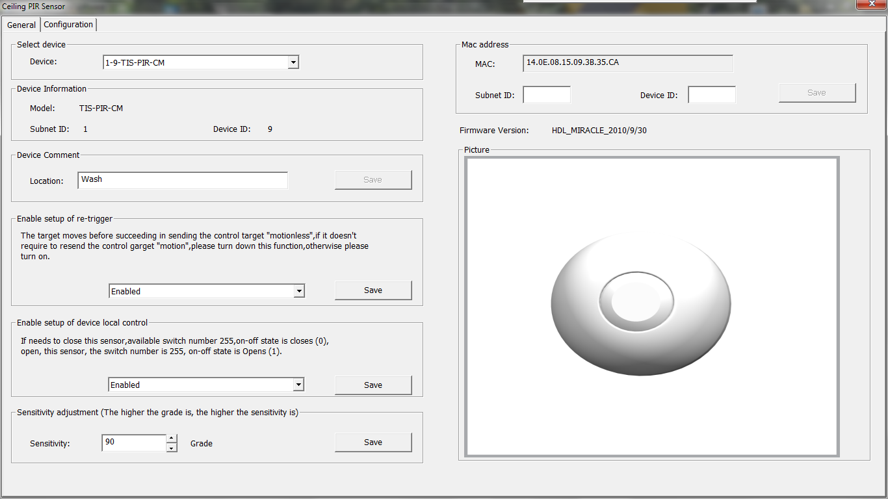

Comments: in the basic setting you can edit the comments of the motion sensor to give it name where the motion installed.
Enable setup of re-triggering: this function if enabled it will trigger all the commands every time the status of the sensor changed from no movement to movement.
If the function is disabled, the commands will not trigger for the second time if there is movement unless the time of no movement finish.
the re-triggering function is very useful, you can disabled in all rooms that people stay in for long time like Living room, bed room, cinema room, so when the first time they enter the room the lights will turn on but while they are staying in the room and change the lights mode it will not trigger again any light if still they are in the room and moving, while enabling this function is useful in the passage , WC and others rooms that we need always lights and no mode to set.

Enable setup of device local control: is to enable the motion sensor or disable it manually from the software, to enable and disable the motion by TIS-bus command see section 9-4.

Sensitivity: you can adjust the sensitivity of the motion sensor depend on the room or passage requirement, you can set it from 1-100,

9-3 PIR Motion sensor Automation setting

- Go to configuration tab
- Set the action type to motion
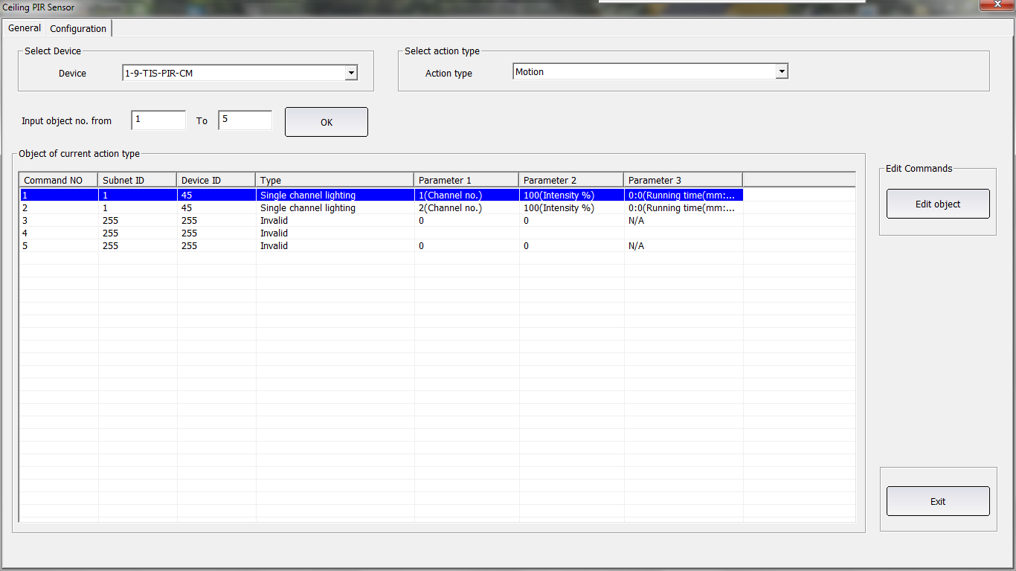

- enter the command from 1-99 that you need when there is movement
- set the commands you want
- select Motionless in the action type
- set the delay time in HH:MM:SS that if no movement for this time the command will trigger
- enter the off command from 1-99
- edit the command of motionless
9-4 PIR enabling Disabling by other Devices
To enable or disable the motion from other devices like LCD, Logic module or other use the universal switch command switch number 255 (ON to enable, OFF to disable)

For example:
If the Motion sensor Subnet is 1, device ID 55

Then in the Luna Panel setting for a button to enable the sensor, it will be likes the following picture:

10- Infrared control

10-1 Infrared Learner
First step of controlling any infrared code of DVD/TV split AC or any other appliances is to learn its code.
To do that connect your IR Learner to your PC USB and configure its driver.
s
TIS IR Learner TIS-IR-KIT is working only with Windows 32 bit so make sure your computer running on windows 32bit operating system or check for latest IR Learner type from your supplier..

Than you can go double click on any IR devices such as 10F sensor, IR emitter or MARS/LUNA panel, go to IR Emitter tab and press learn IR.

Bring your DVD/TV/AC remote and press ready to learn IR , than point out the IR emitter of appliances remote to the black window of IR learner and press the desired button you want to learn.
A massage of success learning should appear.
Next step is to point out your IR learner window to the TV/DVD/Split AC Than you should test this code by pressing test the button
IF you see your code succeed to send the IR and your appliance respond than your code is learnt correctly than you should follow the next steps to save it to your database..
If your code did not control your appliances than please repeat the above steps again .
In Device setup you can add new device or edit old devices name

After that select the device, write the button name and upload to database
IR backup
It is very important to backup all your device code to one file by pressing on Data backup and restore, , saving the code to one file will help you not to lose your time for programming any new project sharing the same appliances brand and codes.

10-2 The 10F / IR emitter transmitting function
Here we will continue what we did from step 1 to step 4 in the Infrared learner.

- Double click on the desired 10F sensor / IR Emitter on the devices list
- Go to Transmitter tab
- Input key number from 1-200 for Infrared memory than press confirm

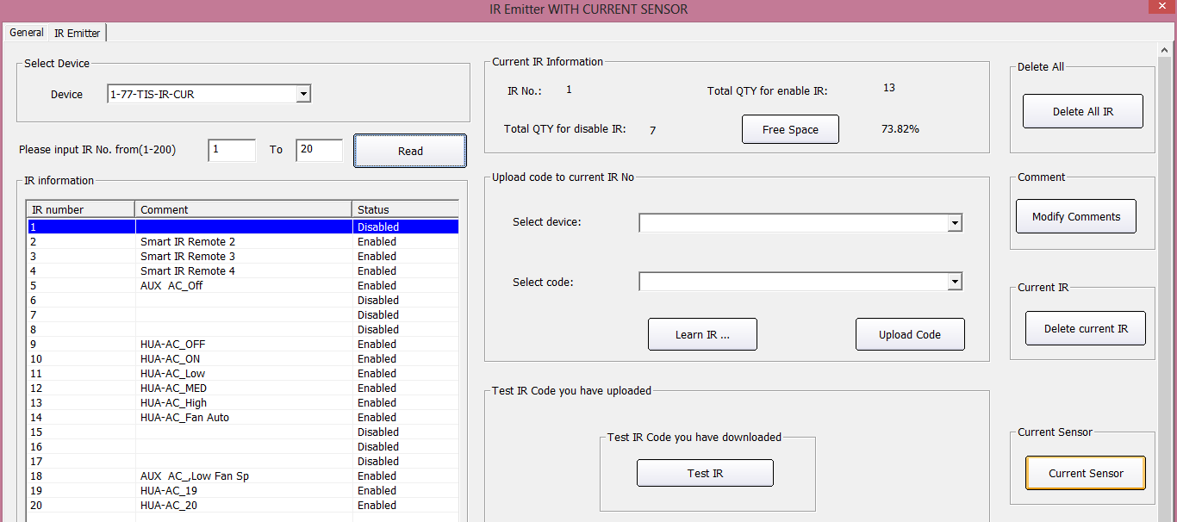

Now step 5 to learn the IR code is to upload the code in your database to the 10F sensor

- Go to code download to current key
- Select device from the pop up list
- Select key of that device from the pop up list
- Select input key number from 1-200 to save this code to.
- Press upload, then a window with upload code success should appear to you.

Step 6:
After we uploaded the IR code to specify location from 1-200 in our Emitter now we must test the code by transmitting it from the Device
- Select the required IR code from 1-200 list
- Press TEST IR for many times after each other
- If your IR is sent without problems and the device work than you are successfully learned and saved the IR

If the following window appears, then your IR code had some problem, you must delete it and return the steps from 1-6 again for it.

You can edit the comments of the uploaded IR code in the 10F sensor by pressing on the Comments button
You can delete the current key of IR by pressing on Delete in the Delete current key
You can also clear all 200 IR code by pressing on Clear all info

10-3 The 10F sensor receiving function
The 10F sensor can receive 12 different codes from the TIS remote control
Each code received can trigger in different way by modifying the infrared mode setup
- Press on the receiver tab in the 10F sensor
- Press on mode setup button
- Select the mode you want to trigger the functions

The main different between Single and multi is that the multi can trigger up to 99 commands while single can trigger just 1 command.

- then you can select the key , edit its Comments , by pressing on the comments button
- Edit its target by selecting from 1-10 confirm then press on Target button
- Edit your commands then save.

- The transmitting function: it can record up to 64(Mars/Luna) or 200 IR code(10F, IR Emitter) in its memory and transmit it to control any IR based control equipment like TV, DVD, AV receiver, Split AC, Fire place …
- The receiving function: it work with TIS remote control only and it receive the IR code from the remote 12 different buttons to trigger for each button press up to 20 commands inside the bus used in 10F / Luna and mars Panel.
Another Important reciving IR funcation had been added to new 10F sensor versions to be able to control related Panel Air condition , floor heater , Music and panic button
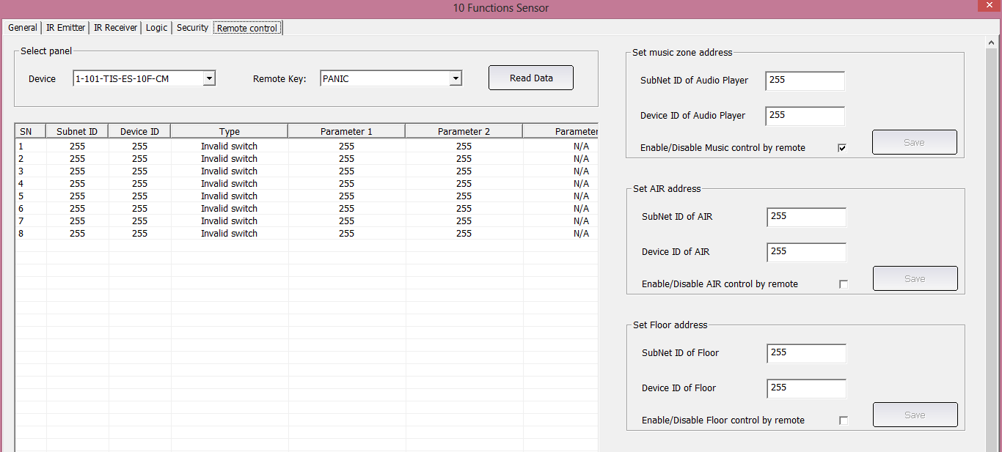

10-4 IR control by bus devices example
Most of the TIS bus input devices can communicate with the 10F sensor and the IR Emitter with current sensor to transmit the uploaded saved IR.
Devices like the Mars/Luna Panel , Logic module, RS232, and the 10F sensor itself can trigger the IR function.

In our example we will take the Luna to know how we can communicate with the 10F sensor to trigger the IR.

Let us take the following example
We have 2 Devices, 10F sensor, and Luna TFT LCD Panel, and we want to control the TV ch+, ch- from the button 1 and button 2, in the LCD Music/AV page, if we press on button 1 the CH+ IR will trigger, if we press on button2 the CH- IR will trigger from the 10F sensor.
How to do that, Let us consider that
10F sensor address is subnet ID 1, Device ID 15
The Ch+ is saved on location 3 in the 10F sensor of (1-200 locations)
The Ch- is saved on location 4 in the 10F sensor of (1-200 locations)

To do the above example, do the following:
- double click on the Luna LCD in the device list
- go to Music /AV function
- Select AV1 button and read the commands
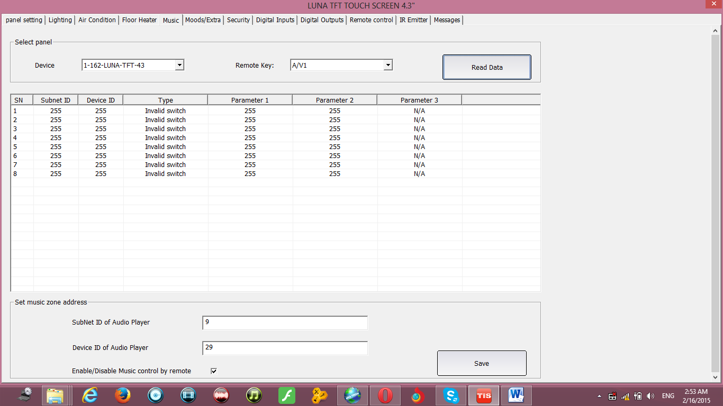
- edit the close function to trigger the subnet 1, device id 15 (10F sensor address) , type universal switch (to trigger the IR) , Parameter1 “4” (location 4 CH-) Parameter2 ON.

- then go to AV2
- edit the open function to trigger the subnet 1, device id 15 (10F sensor address) , type universal switch (to trigger the IR) , Parameter1 “3” (location 3 CH+) Parameter2 ON.
- save and test the button and the function

10-5 LCD and control of split AC Infrared
There is very important facts you should know about the split AC IR remote control code that differ from the normal TV or DVD remote control.
The first fact is: the power ON code, and Power off code for the split AC remote is different, even it have same button to turn the split AC on and off but the code for ON is different than the Code of OFF, and each time you press the remote toggle between this code, while in the TV or DVD remote the IR code of ON and OFF is same.
The second fact is: the UP/Down, button in the AC remote control to rise and decrease the Temperature sending different IR code for each set of Temperature, for example 21C, is different from 22C, 23C, 24C … each one has different code, even the same button UP is press but each time is sending the temp code of what is showing on the remote LCD. Unlike the TV or DVD remote that sends CH+ always same code each time. The same concept also covers the Fan speed and AC mode.
You have to take the above 2 facts in your consideration when you want to learn the IR code for split AC.

Controlling Split AC from the LCD:

To control Split AC from the LCD AC page do the following
- double click on the required LCD on the Product List
- go to the popup menu for the Infrared control and select the commands you want to assign the IR to it

- assign each command to its IR memory place in the needed 10F1 sensor

The above Picture show that the LCD AC page cooling Temperature Degree is assigning to its IR that saved in the 10F sensor that have address subnet 1, device ID 15.
For example the 17C command, its IR is saved in the 10F sensor memory location 20. While 18C command saved in location 21 and so on for the rest of commands like FAN speed, Cool heat mode, ON, OFF, etc…

After you save you can test your program, go to the LCD, change the page to AC page press ON, the IR for ON from the 10F sensor should be sent, Press OFF the IR for OFF from the 10F sensor should be sent, try to change the cool Temp Rise it 18C, 19C, 20C, Different IR from the 10F sensor should be sent 18, 19C, 20C and so on. .

Try always to use memory location in the 10F sensor refer to the command, so it is easy for you to remember, for example, you can save the 17C IR in memory location 17, 18C in memory 18, and so on so later you can assign the command in the LCD easier.

Automatic control Function:
This function if enabled
- it will send the Fan command automatically when the desired Temperature equal or below the room Temperature.
- It will send the cool or heat command if the room Temperature again rise or go below the desired Temperature

Automatic control Function is not recommended to be enabling if you are controlling the split AC, because the split AC have it’s built in Temp sensor and can automatically off its heat or cool compressor.

Automatic control Function is very useful if you want to control Floor heater or third party Air condition using the RS232 ASCII and Hexadecimal Strings.

11- Automation, the 10F Energy servant Function
11- 1 Introduction
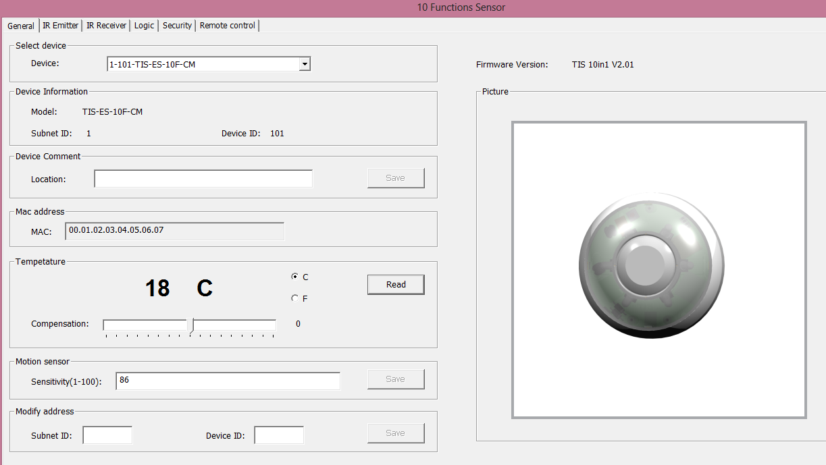
The 10F sensor has 32 lines of Logic with AND / OR conditions that linking between its input and 40 universal switches (Flags) to help you in programming for different scenario and conditions.

The 10F sensor has 2 Dry contacts to connect door contact, break glass smoke detector or any other type of digital sensors. Also it has Light intensity sensor and motion sensor.

The following steps needed to program the logic function of the 10F sensor

- Double click on the 10F sensor in your device list
- Go to logic function tab
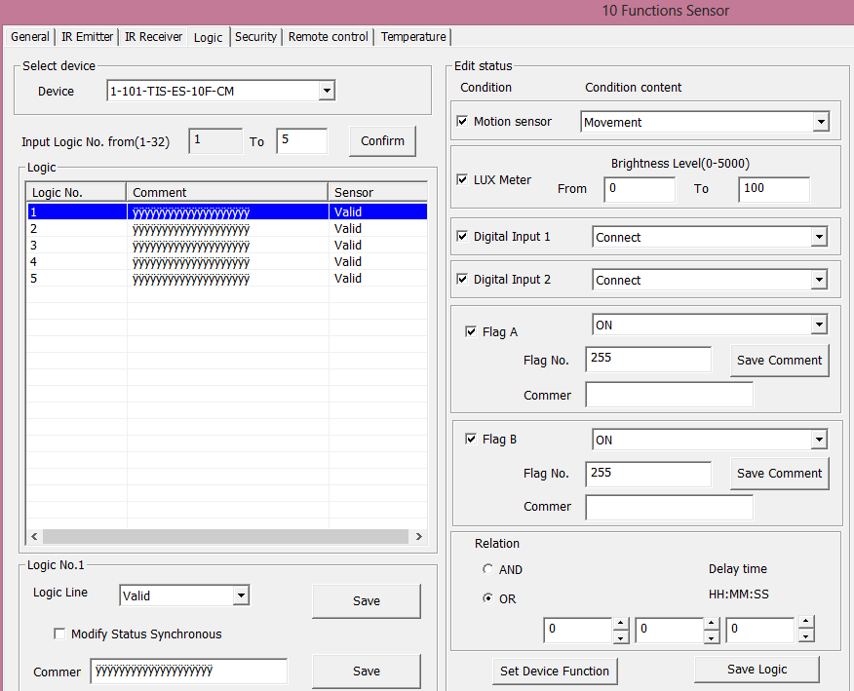

- Select the logic from 1-32 and edit it comments, and make it valid/invalid.

11-2 Basic setting
Motion sensor sensitivity
This will affect the motion sensor sensitivity you can adjust it depend on the place of installation, if you need the motion to be more powerful or less powerful. It can be from 1 Low, to 100 high..

Set Device Function:
This feature allow you to enable or disable the input of your 10F sensor
- Press on Set Device Function
- You can enable/disable any of Dry contact 1 (Digital input 1) , Dry contact2, External condition1,2 (FLAG A, B), Lux sensor and Motion sensor.
Also you can Enable and disable any of this input from other TIS bus devices using the universal switch command and the corresponding switch number t each input, Parameter 2 ON for enable, OFF for disable
Input name | Universal Switch number
Dry contact 1 | 251
Dry contact 2 | 252
Lux Sensor | 253
External condition 1 | 254
External condition 2 | 250
Motion sensor | 255

11-3 Logic and condition
The middle part is the condition setting of Logic, by checking/unchecking and select its value , AND, OR and Delay time condition you can make your logic

current status button will show you the status of your 10F sensor inputs like the status of the motion sensor, the exact value of lighting intensity, the Timer value for the current condition, the Dry contact 1, and 2 status if open or close, Flag A,B value.
Every time you press on Read or Refresh button it will update you with the current status.
The status of each input can be shown on this screen

- Edit your condition
- Select the inputs you want to create from it a logical condition for example you want the motion sensor and Lux sensor to be part of your first Logic line. Then select it by the check box and remove the other no need input.
- Select the status content, for example motion sensor (movement/no movement), Lux lighting intensity range between 0 to 20 (Dark)..
- Select the Relation AND or OR so the condition will be, if motion movement AND LUX between 0-20 , or the condition will be if motion movement OR LUX between 0-20.
- Select the delay time, if this condition happened for how many time it must be exist in order to be true and the command will trigger. Make it Hour 0: minutes 0 : seconds : 0 if you want the command to trigger directly if the condition you but is happened.
- After you finish your condition press on SAVE LOGIC button.

11-4 Commands

After you finish your logic setting than set your target commands that will trigger if your logic condition is true.

You can make the same steps for the other 32 Logic Line
For example you make Logic 1 for movement if someone move to turn the Lights ON, you need to edit another Logic to off this light if no movement and set the delay time for 5 minutes so if no movement for 5 minutes it will turn the lights OFF, see the following picture

You can also make logic for the dry contact 1, or dry contact 2 that if connect or not connect, for example if you connect to dry contact 1 a door sensor and you want to program if someone forget the door open for 3 munities to turn the Air condition off

Flags A,B:
The 10F sensor has Flags to help you in programming to make your logic and automation more powerful.
As you know also you can use 40 flags in your logic condition.
For example you want to have Movie mode that will trigger the move scene and in this mode you don’t want the motion to be active than you can add Flag number to your logic and assign it for movie mode and edit it comments to fit with the mode you want.
See the following example

if Movement AND Flag A 200 (Movie mode) is OFF then command turn on the light.
In the LCD Panel you can assign a switch call it movie mode to turn the universal switch 200 ON/OFF for movie scene.

If you want to use the flag A and B you can only use switch 200 to 240 .

12- Automation Timer Module
This device has built in clock and logic that will help to make automation based on Time, Date and sunset sunrise with other advanced data from the bus network and devices…

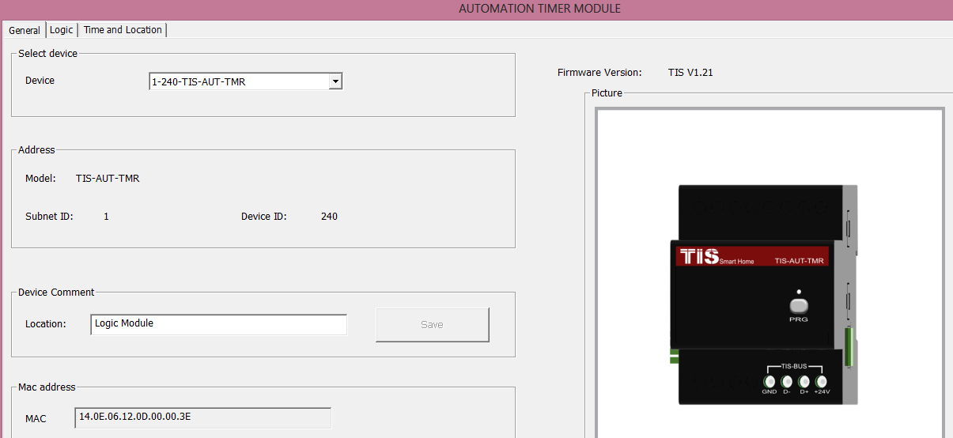

12-1 Time and Location setting
First you should set your device correct time and your city location
Go to Time and Location tab

Set the Time and Date, you can get your computer time by pressing on Get PC time as fast setting than save the time, also you can edit the time manually and save it.
In Geographic location you can press on location button and select your city from the database than save it .
If you did not find your city in the list, than you can search in Internet for your city Latitude and longitude tan edit the data manually and save.

Time Zone is important you can set your Time Zone ..
Daylight saving Time setting for country used this method to shift the clock one hour before or after once a year in specific date.

Setting your Time zone, city location , date and time is important to get the sunset sunrise daily time that will help in your programming

Broadcast Time is important function to share device time to tis bus network and devices, so panels like Luna can sow the time and date on its LCD.

Method for Prayers Time if you click on it than the Muslim daily five prayers time will be included to your logic. Other setting of Prayers calculation depend on Muslim Calculation methods is covered by many options.

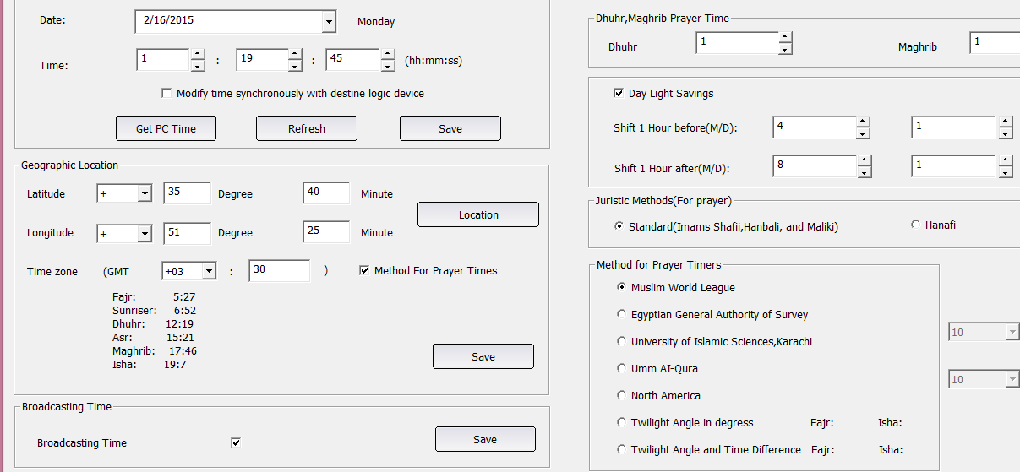

12-2 Logic Function
In Logic tab the device has 20 logic numbers, in each logic you can configure 20 tables.

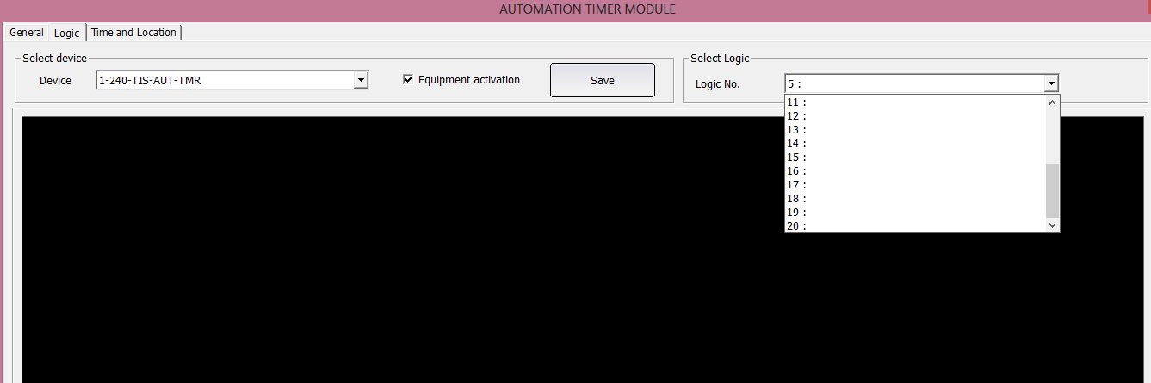
Select any logic number from 1-20 than right click on the black area than select Modify Logic Diagram, Also you can double click on the black are to edit the logic

On the logic you can write the comments of the logic than press modify comments to save its name..
Than select your table type (AND, OR, NAND, NOR) by pressing on it to select, than pressing on any place on the black area to drop it

Right click on the table and select Pin Setup (by double click on the table you can go to pin setup directly)
For each table you will have 4 pin setup as a condition input of your logic.
You have the relation of logic, Delay time of your condition and the type of your condition

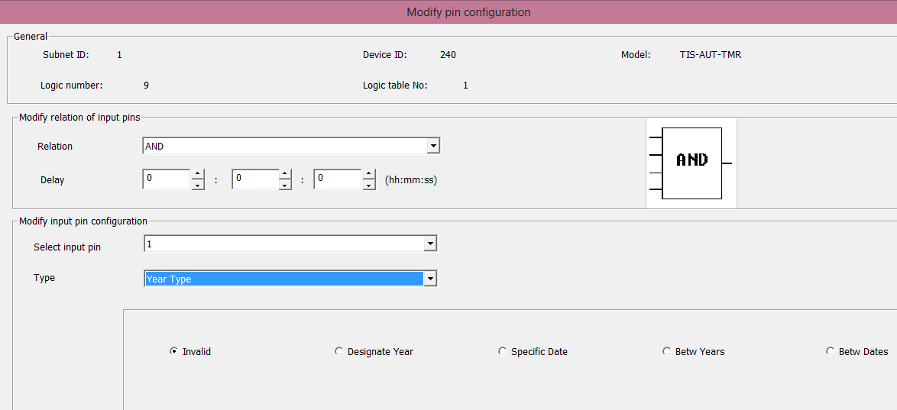

PIN Type | Description
Year Type | You can edit your table condition to work on specific year or between year to year.
Date Type | You can edit your table condition to work on specific Date , for example birthday or anversary remainder , or between date to date like a seson (summer, winter) or every month from this day to this day like everymonth remainder of payments or others .
Week Type | To wok at one weekday or from day to day like from Monday to Friday and so on.
Time Type | At time, At sunset, Sunrise, Prayer time, or before after sunset sunrise prayer time, or between time to time
Logic Switch | Is a Flag from 1-254 used to help you making more condition in your logic , Ir can be set by universal switch command , it take 2 values ON or OFF  Automatic detect retrigger function is to run the commands for every time a universal switch command received without the needs to change the flag status
Exterior Input Value | To read the temperature sensor value of other devices or any analog inputs to use it in logic condition.
Device Scene Status | To detect Dimmer, relay and DMX scene status to use it in logic condition.
Device Sequence Status | To detect Dimmer, relay and DMX Sequence status to use it in logic condition.
Device Channel status | To detect any output device channel status to use it in logic condition.
Panel Control status | To detect Panel Air condition status to use it in logic condition.
Universal switch status | To detect Curtain switch of any Motor status to use it in logic condition.
Curtain Switch status | To detect universal switch of any device status to use it in logic condition.
Security Module status | To detect Security module Arming levels to use it in logic condition.

After you set your Pin inputs than you need to trigger the commands output
Right click on the table than select Modify command for current table than write the commands you need , after you finish editing you can press the Save button and test your table..

Comments is Important to be set for better understanding of the tables of logic,

13 Security Module and security zone setting
13-1 introduction
TIS security system is a bus system using its motion sensor and dry contact with its Security module to make a logic of arming disarming and alerting …
To make security system you need at least one of the following
- Security module
- At least one motion sensor for example 10F or any sensor connected to dry input.
- Siren/flasher connected to one relay panel
- Luna panel to arm/disarm the system
SMS Module and UPS is optional to enhance the security system ..

Security module setting:
It has 8 areas that can be cinfigered , armed and disarmed separately , so it can support 8 different locations, area or apartments .
General Setting of security Module:
You can set the time of the device, day lightsaving time, subnet and device id, and comments of the device .
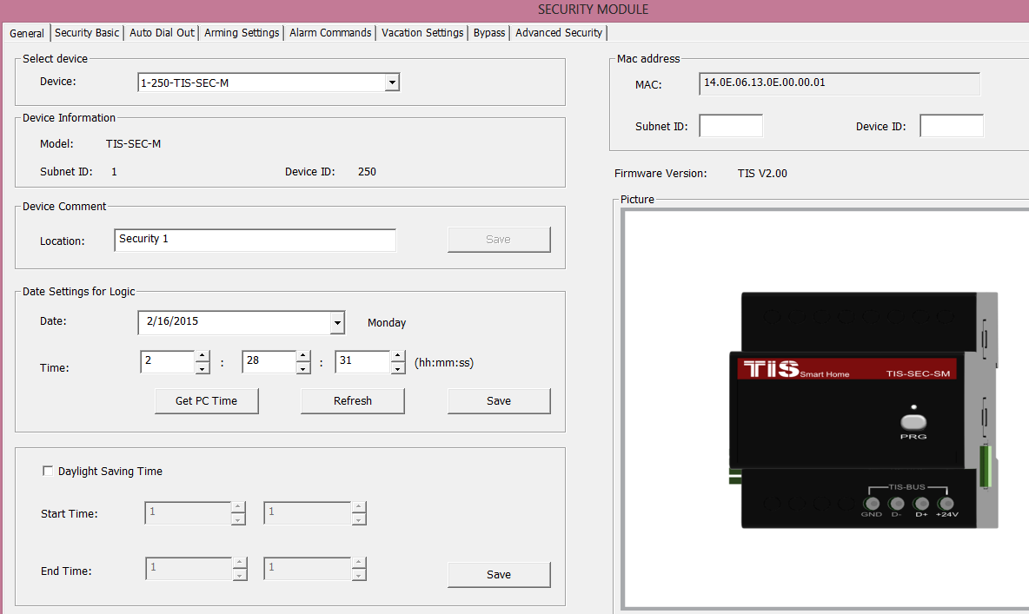

13- 2 Security Basic setting:
In security basic setting there is important value to be set.
Function | Description
Siren Delay | To give delay time for end user before siren start to avoid direct annoying in case of false alarm
Entry Delay | To give a time for end user to reach his panel to disarm the system in all entry delay zones..
Reset after Alarm | To turn of the siren/flasher after Alarm start if there was no more movement or breaking in the armed area. This to stop annoying neighborhood
Exit Delay | To give a time for end user to Exit the armed location before the system arming activation..
More people leave mode | It is exit delay tome restart , so it will reset the exit delay timer every time end user move under sensors or open doors until the system make sure the end user leave totally
Buzzer On | Will be activated in entry and exit delay
Buzzer off | Will be activated in disarming or when the exit delay time finish
Alarm buzzer on | Will be activated in alarm
Alarm buzzer off | Will be activated on disarm
Siren ON | Will be activated in burglary alarm after the siren delay directly
Siren off | Will be activated on disarm
Fire siren on | Will be activated in fire alarm
Fire siren off | Will be activated on disarm
You can set the subnet ID device id command of each type of buzzer and siren for the Luna buzzer or relay switch connected to buzzer flasher and siren ..
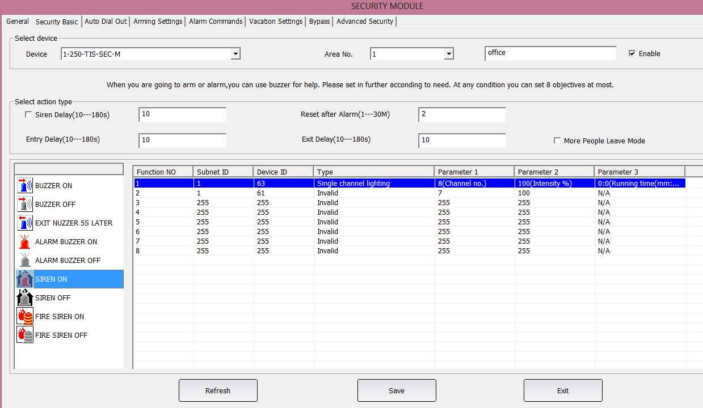

13- 3 Auto Dial out:
You can set the delay time to start dialing, and the command to trigger the sms or auto dialer that connected to your system
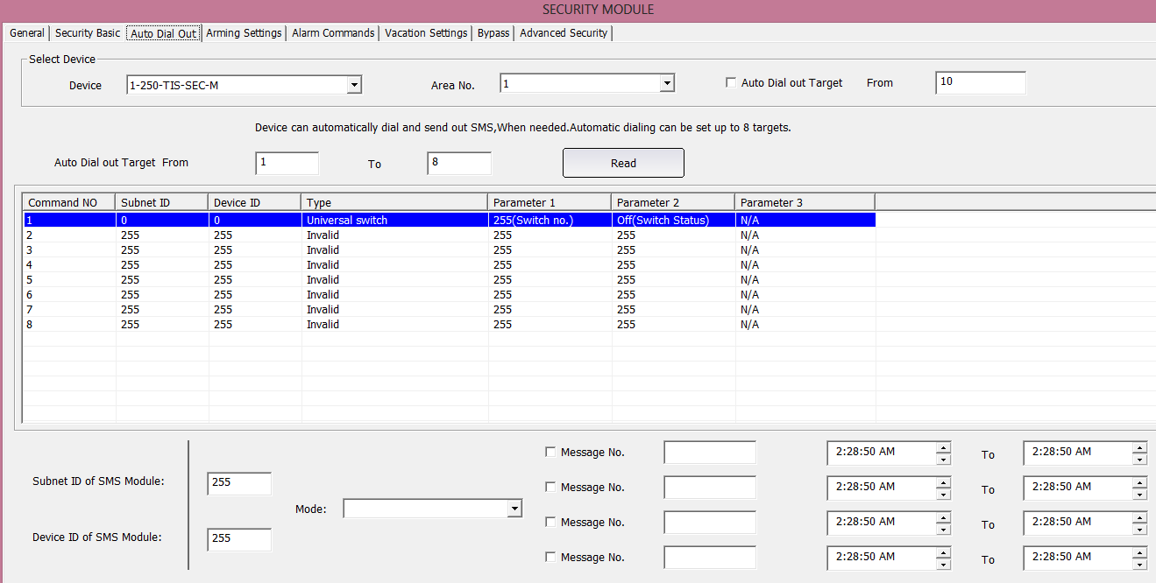

13-4 Arming setting:
You can add additional commands while or after arming
By activating the trigger when leaving than it will trigger all commands after the exit delay.
You can add extral commands like turning off all lights, set Air condition temperature and more in each arming mode.
Error Arming commands will trigger when the auto bypass disabled and some of zones is not ready for arming like door opened for example..
Auto Arming to specific mode can be done daily at specific times
Auto disarming if Arming mode also can done in specific time
For example disarm system if Arm was Night at 9 AM
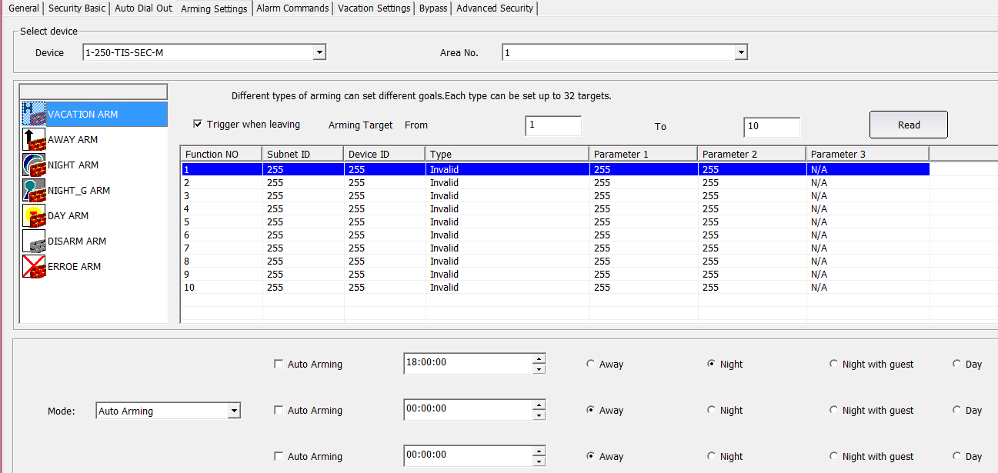

13-5 Alarm Command
You can set extra alarm commands like turn on all lights, turn on music and other function to make the intruder scare and alert everyone..
You can set many commands in alarming different mode for vacation, away, night, also you can set some important command for fire alarm like to turn off all Air condition, open all exit doors and turn on emergency lights.
Reset Alarm command is the command will sent after alarm reset time finish.
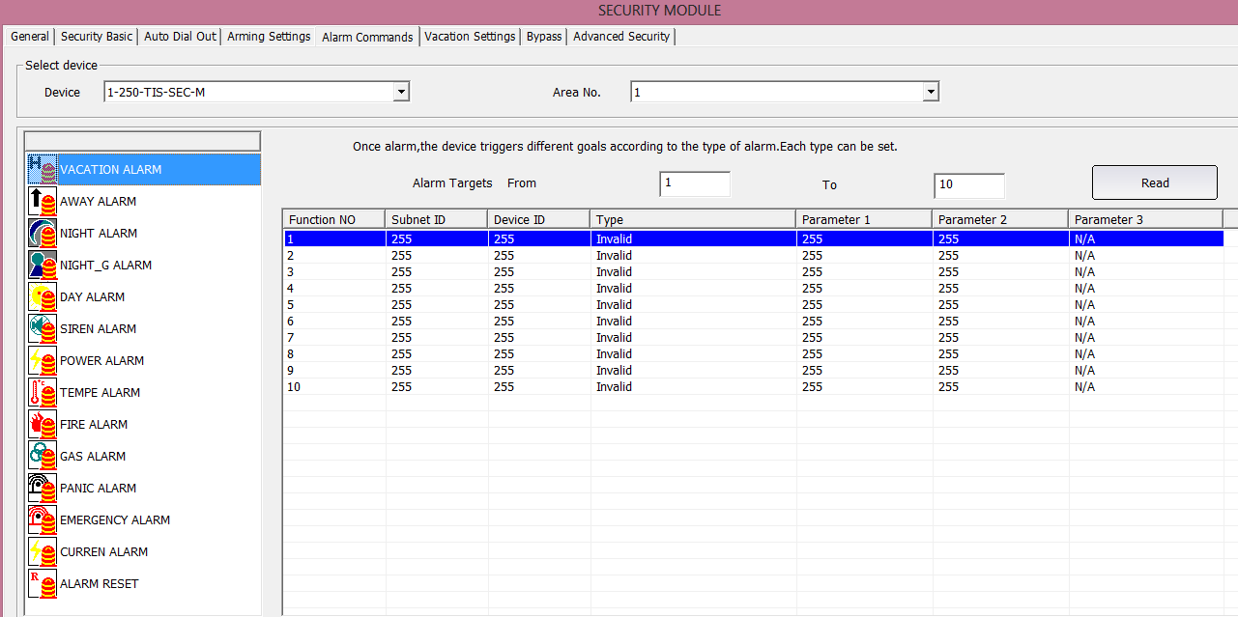

13-6 Vacation setting:
It will be enabled only in vacation arming mode, you can set different command to run randomly in different time to make the area look like active area by turning some lights, music, on off.
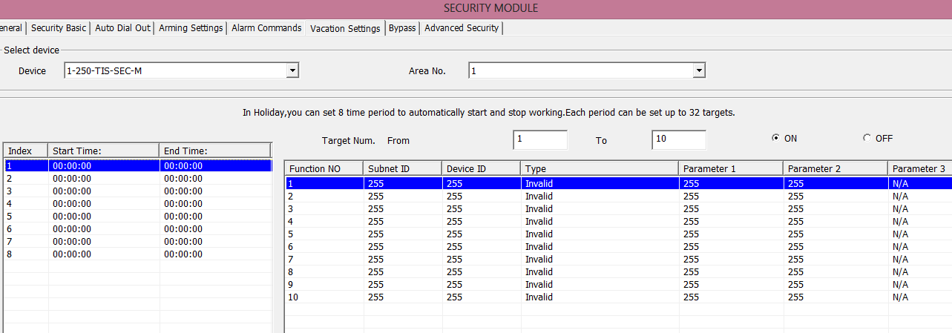

13-7 Zone Bypass
The default is auto bypass that will ignore if the security zones is ready or not ready, while if you disable it than it will start checking all the address of the zone you put in the table , and will not allow arming of the system , aslo will trigger the error alarm command that you had set earlier .

13-8 Advanced Security:
You can have additional 9th and 10th line of defence by adding more protection command to protect your area
This command will be activated in 2 conditons
If time of alarm remain more than XX Minutes in case the armed was in specific arming Mode
Or in case of XX seconds passed after panic button pressed

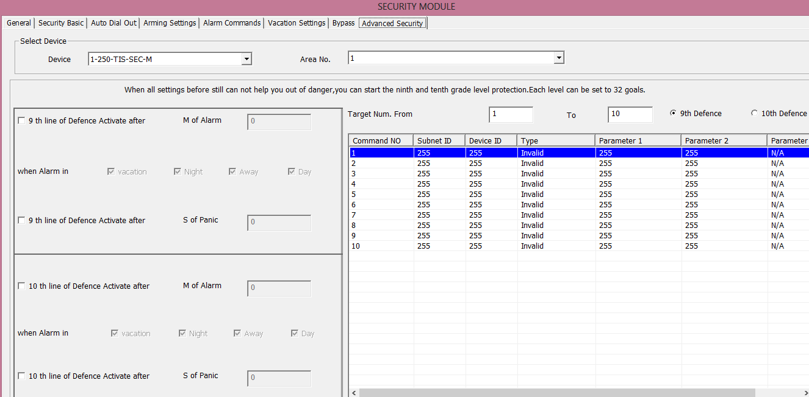

13- 9 Sensor , Digital Inputs , security zone setting:
Each sensor or dry input has security setting , you can enable each security zone or disable it.
Also you can select your connected sensor as NC Normal close, or NO Normal open .
In security module you should put the subnet , device id and area of the security module ..
Select mode is cosist of 2 method.
- 24 hours active zone, this zone is always active even if the system is disarmed ..
- Other security zones: Are the zones that will be aremed depend on the arming mode.
In 24 hours zone you can configure your zone as fire, Gas, Panic button, Duress button, or current power failure.
In other security zone you can configure your zone to be active in one or more of arming mode like Vacation, away, night, night with guest, day.
Also you can configure the zone as delay zone or direct zone.
For Delay zone you can set it as 1X 2X , or 4X this will affect the entry delay time that will be multiply by one, two or four times depend on the zone type.
For expel if you have outdoor gate than if you set it as 4X and if the entry delay time is 30 seconds than the system will give you 30*4= 120 seconds to enter and disarm the system.
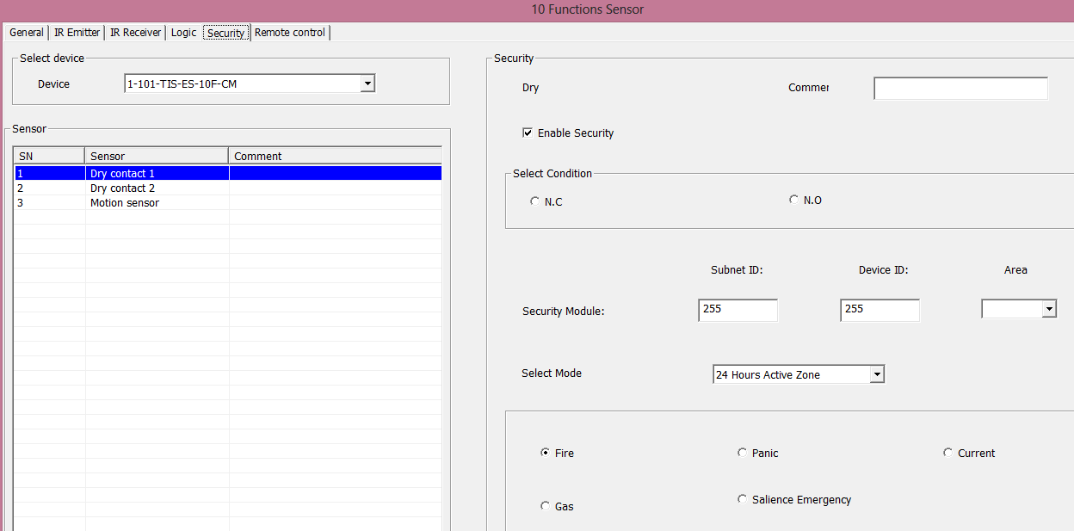

14- Devices Backup and restore

When you finish programming your project it’s very important to make a backup of all your devices in one folder.. in case in future any programed changed or for replacing any items you just need to restore the file you backup it to the new installed device..
Also backup and restore is important for big project of typical units, so you program one of it and then copy the same program to all other units
To do the backup please press on backup on the main menu

Than press Save as and enter the file name and press save
Than press start the backup, than it will start saving your selected device from 1-100% to the file you select.

When it reaches to 100% it will show successfully backup done

To restore your backup file to any other similar type device, for example a sensor you need to press on the restore button
Enter the subnet and device id of the new sensor for example
Select the file you saved before from select..
Than press on the restore button..

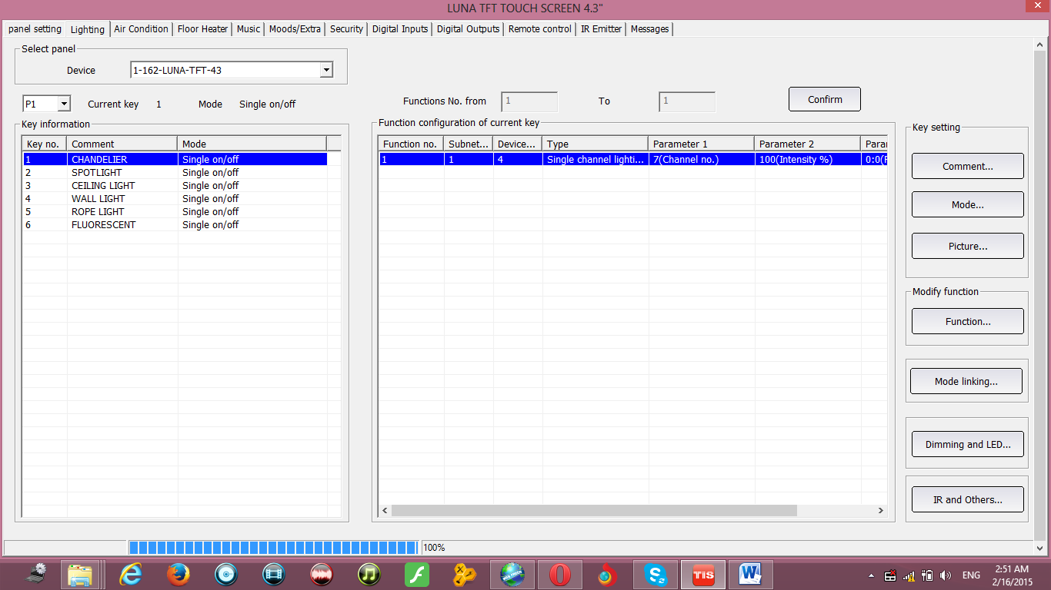
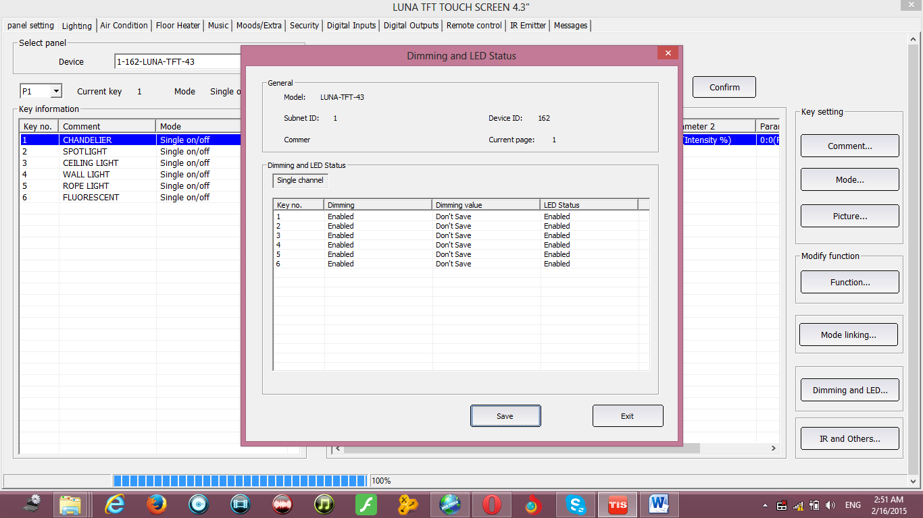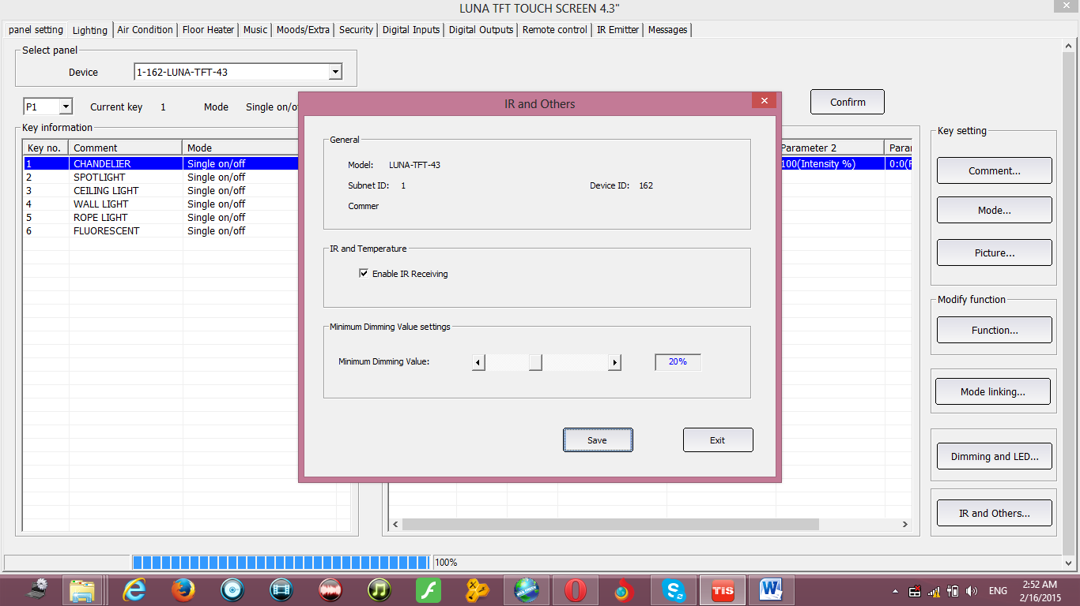
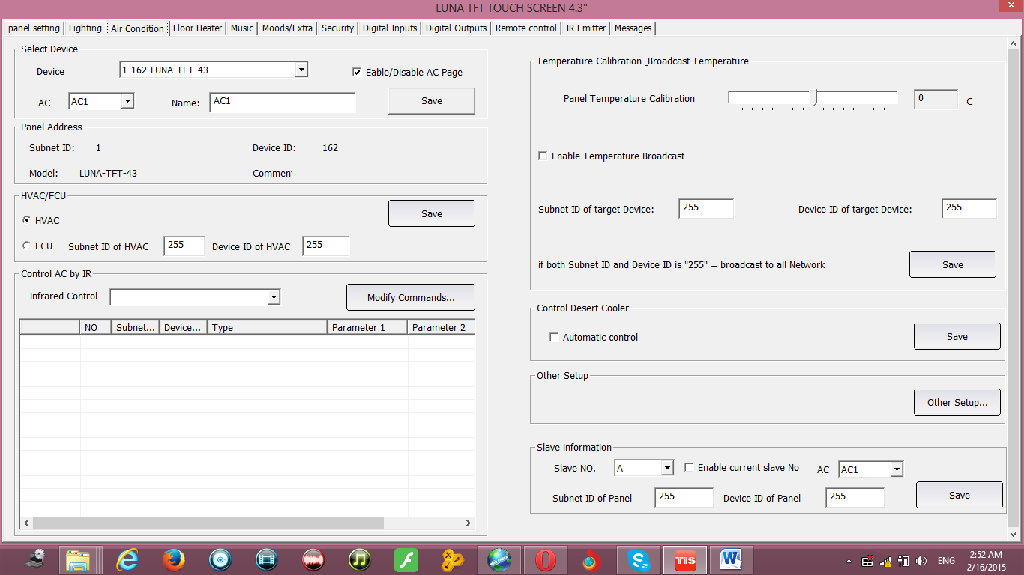

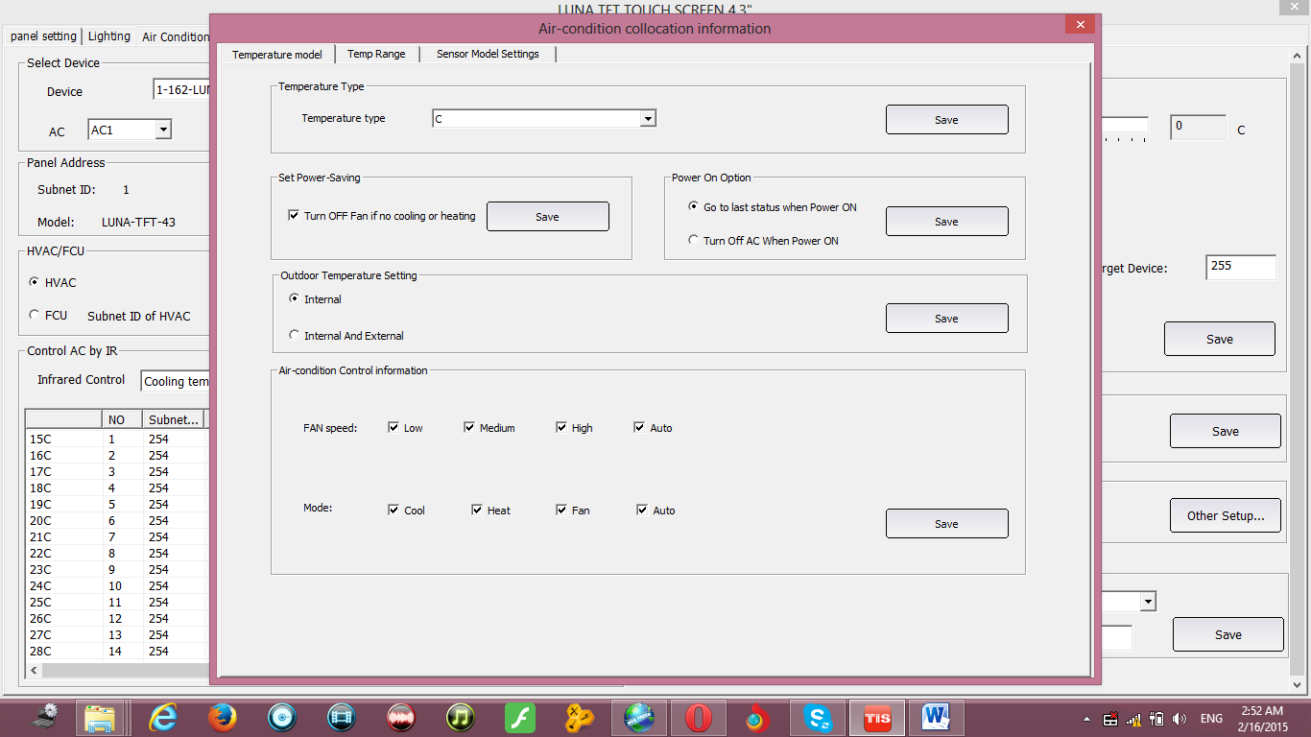
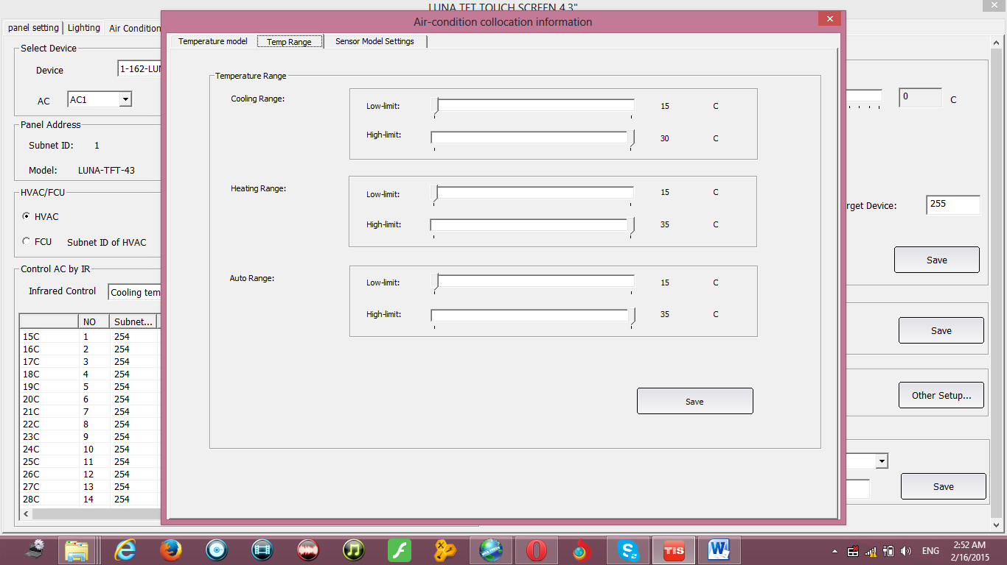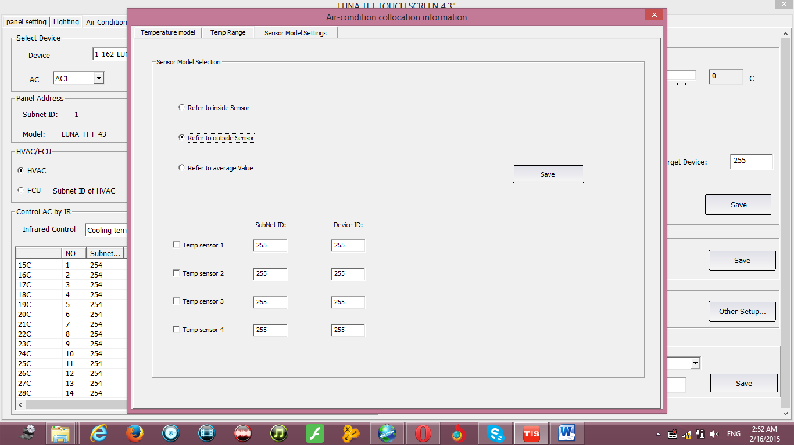
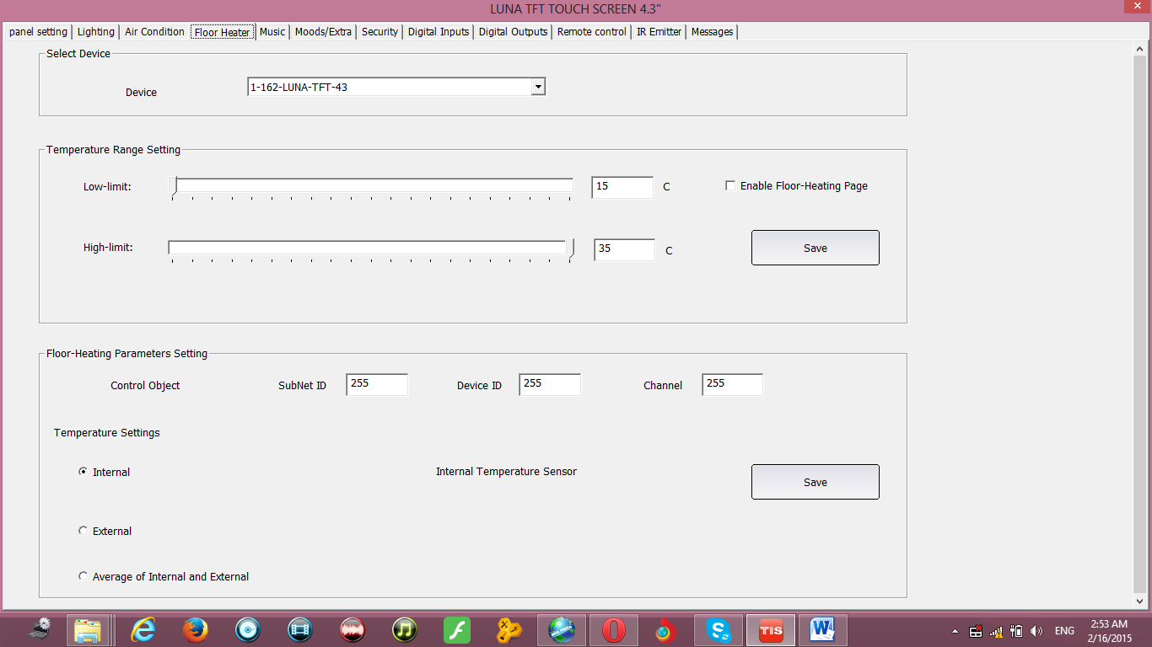
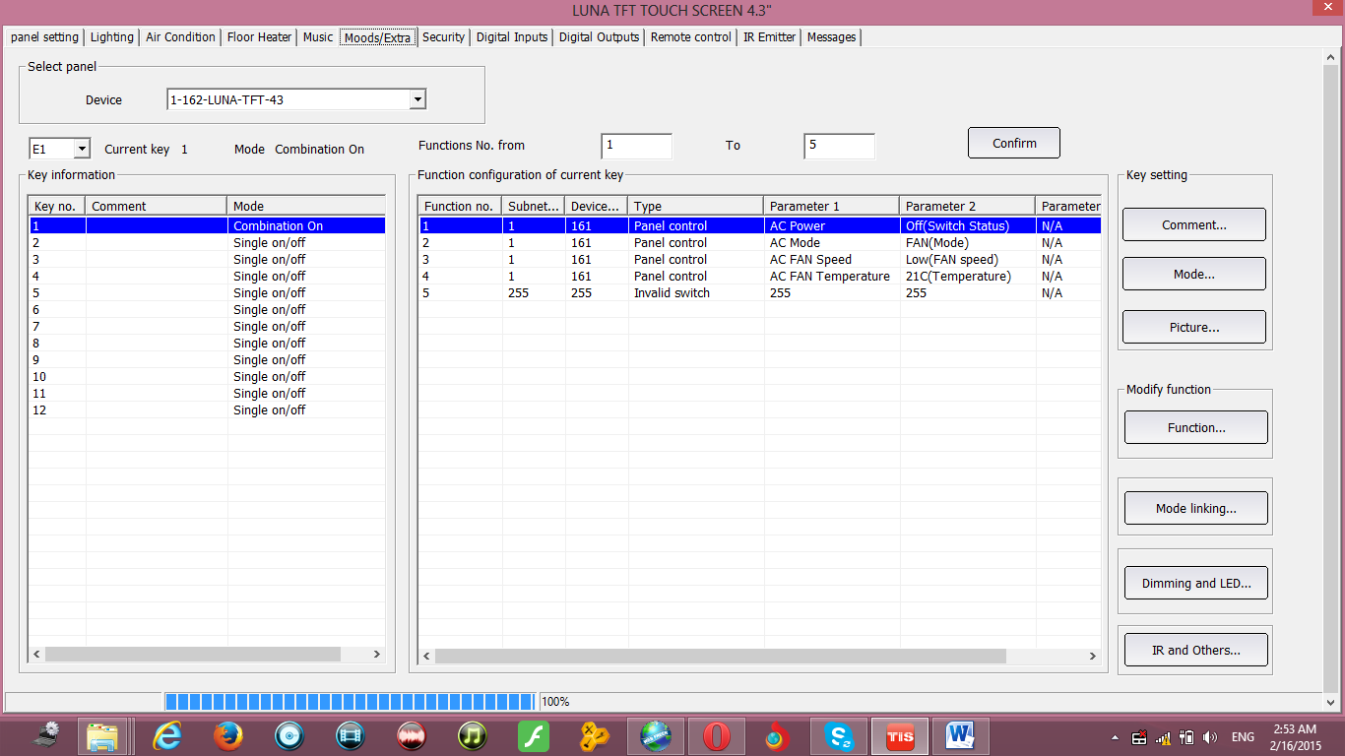
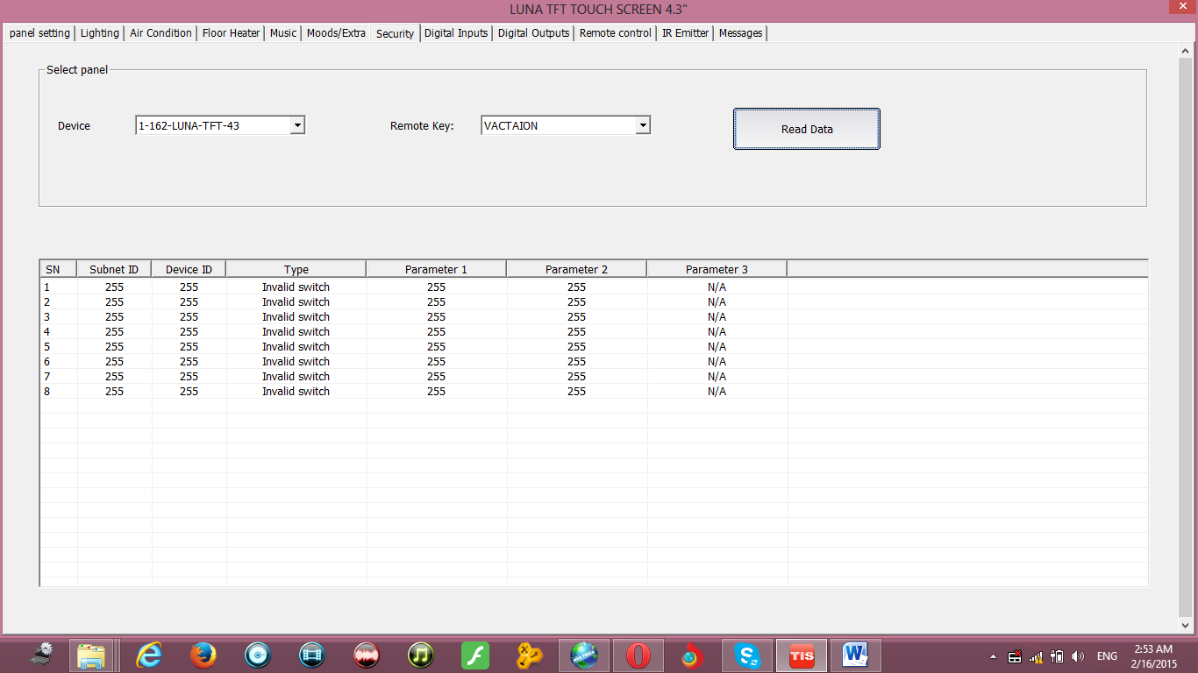
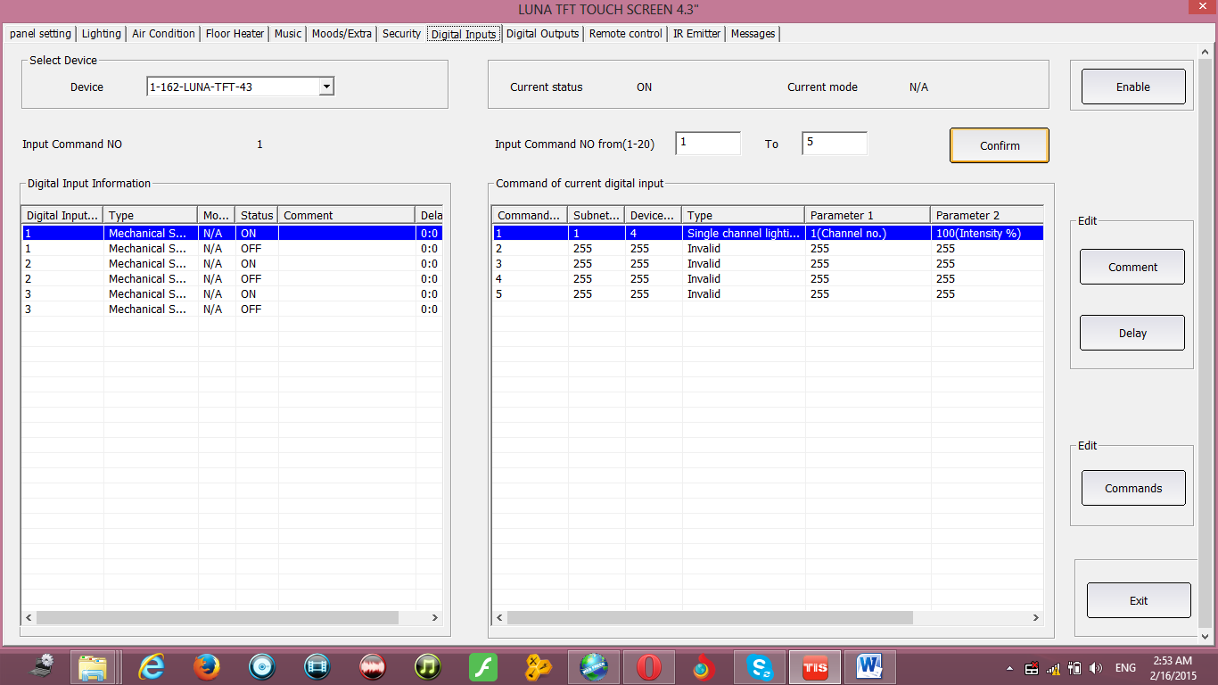
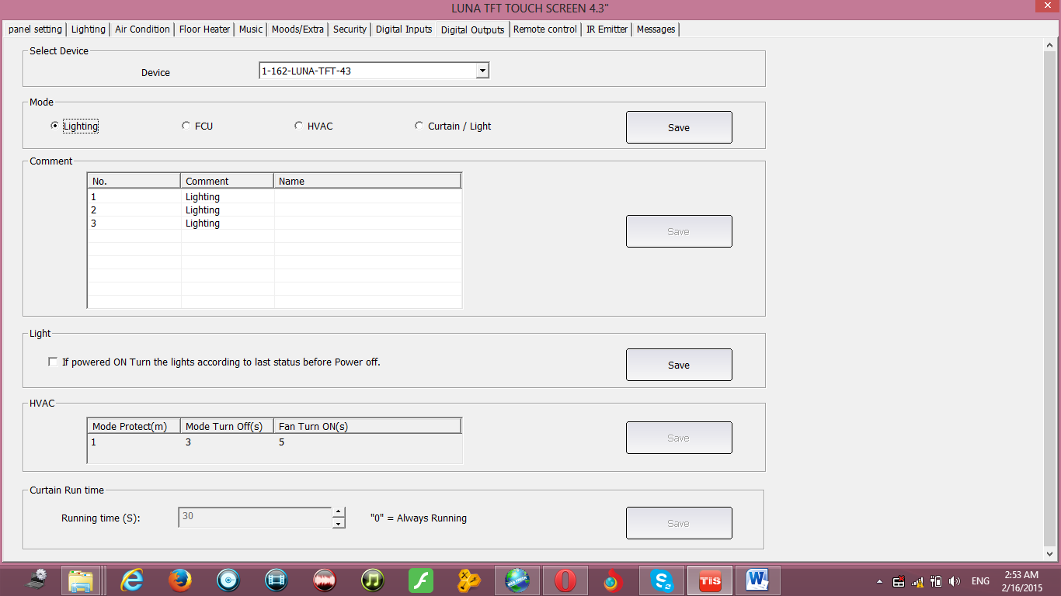
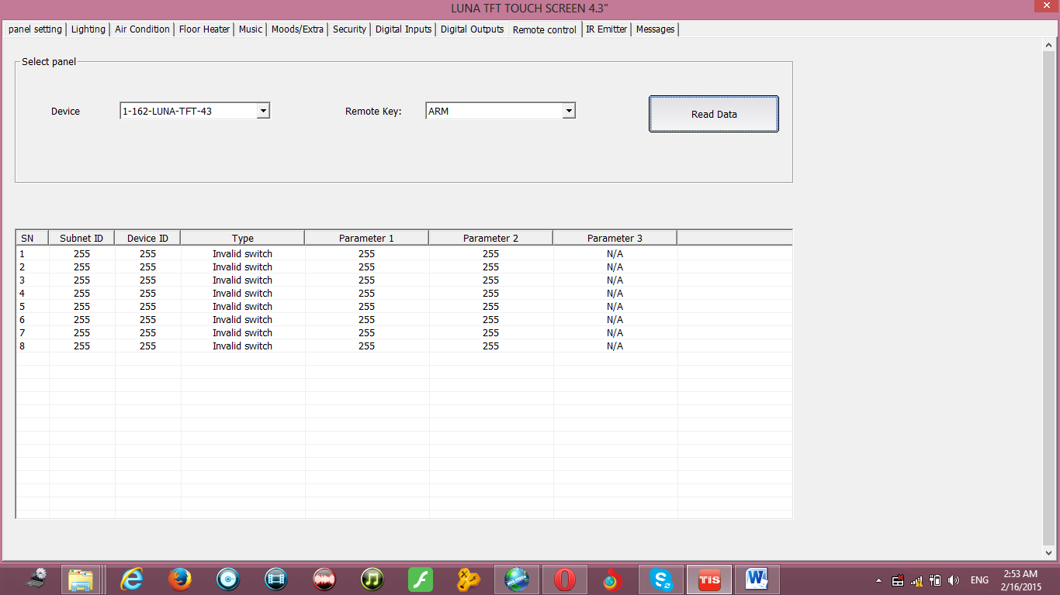
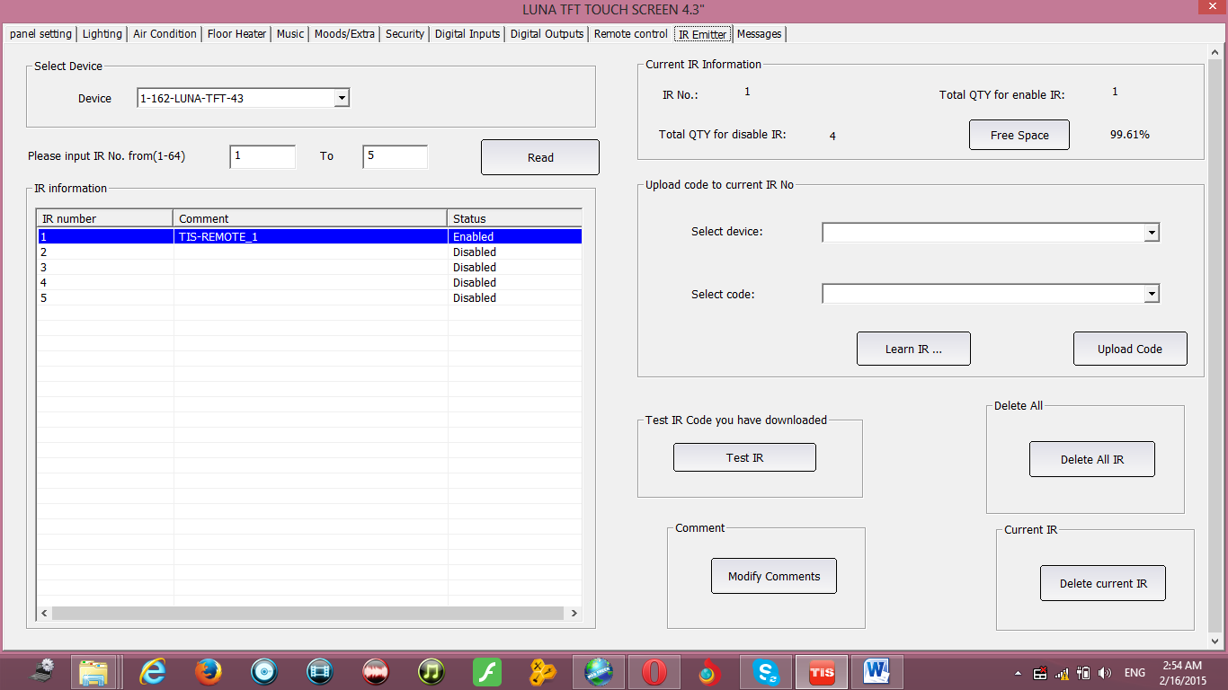
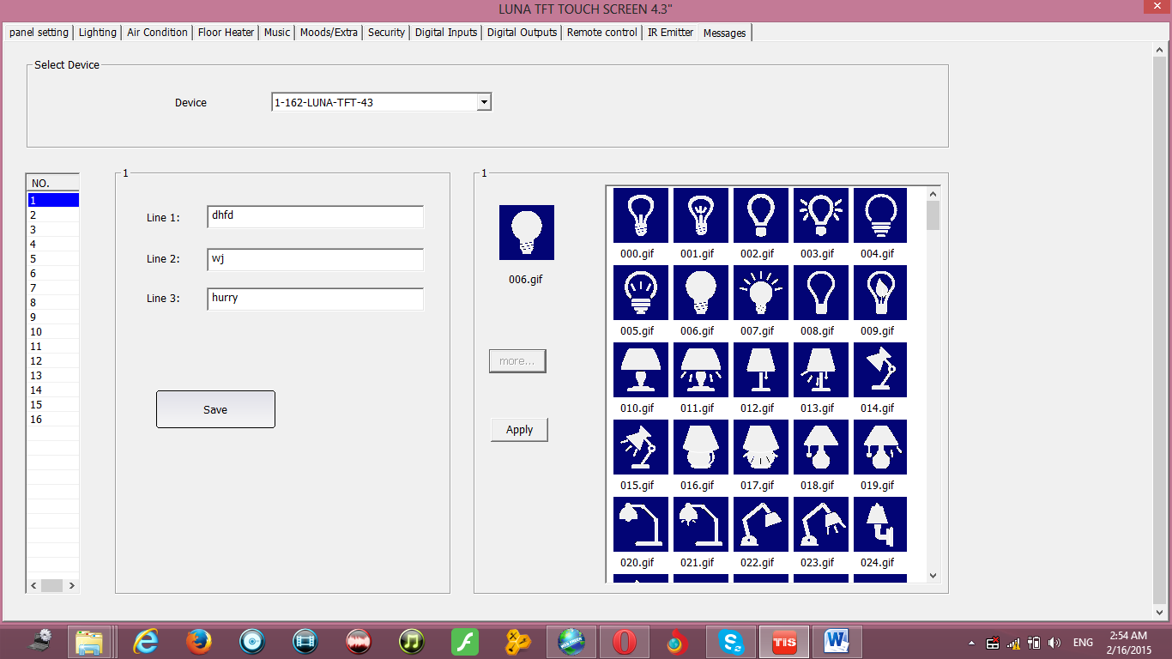
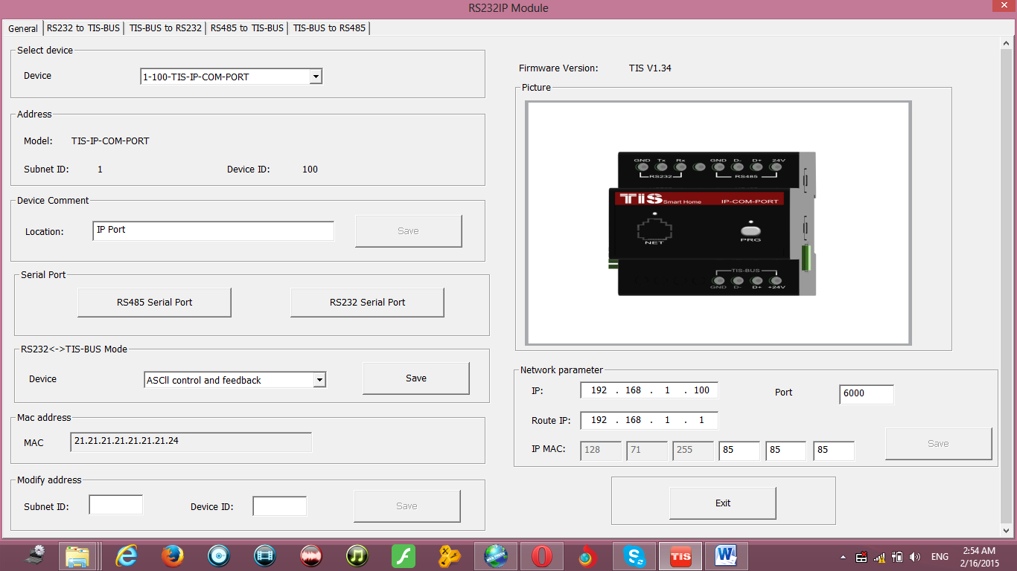
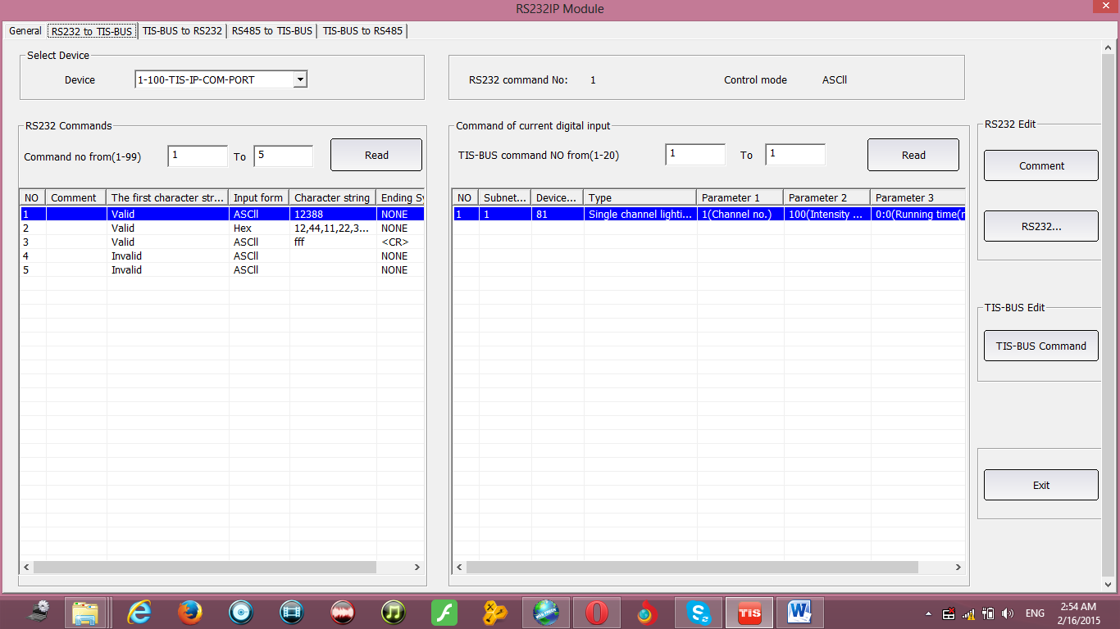
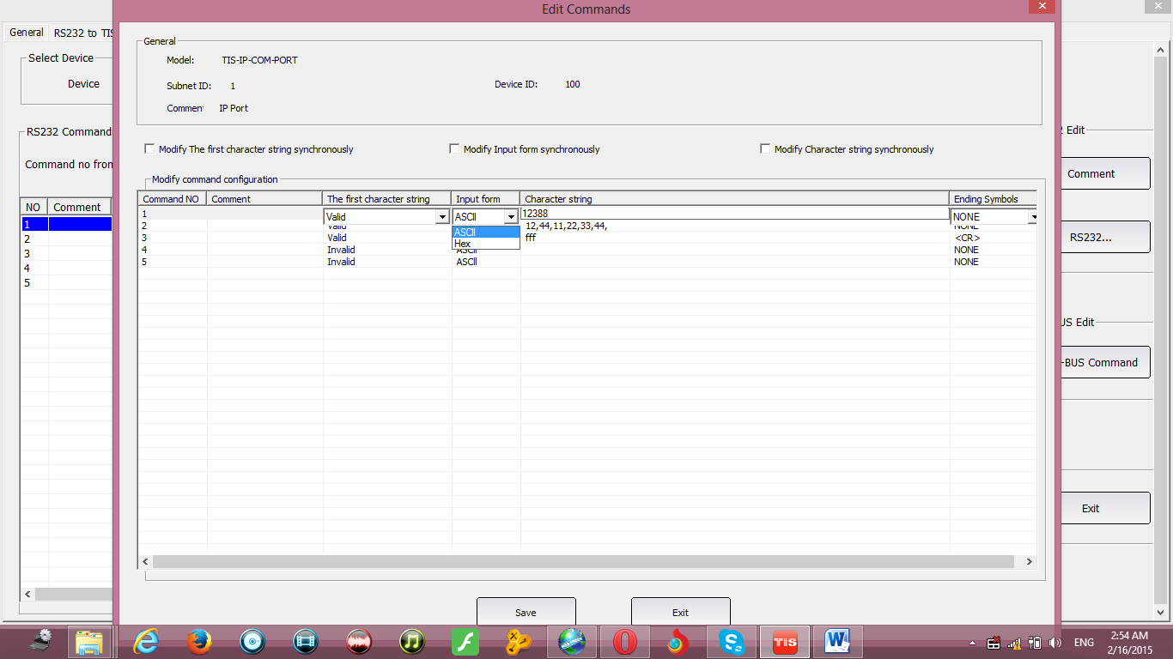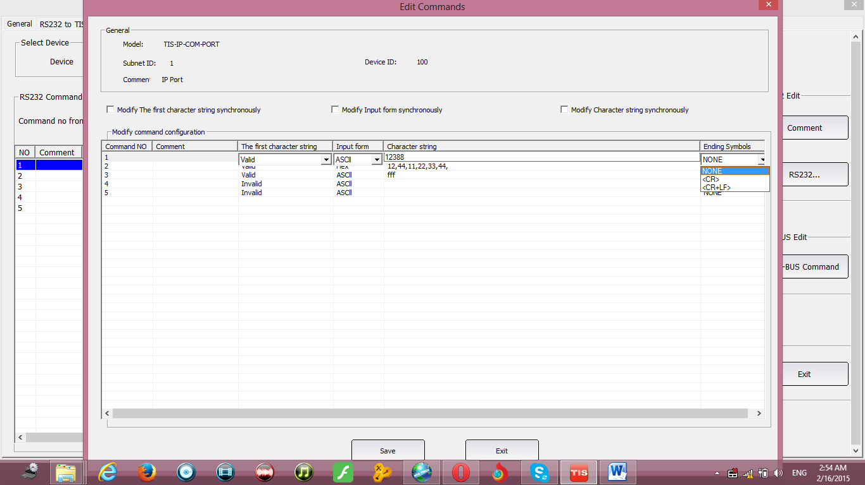
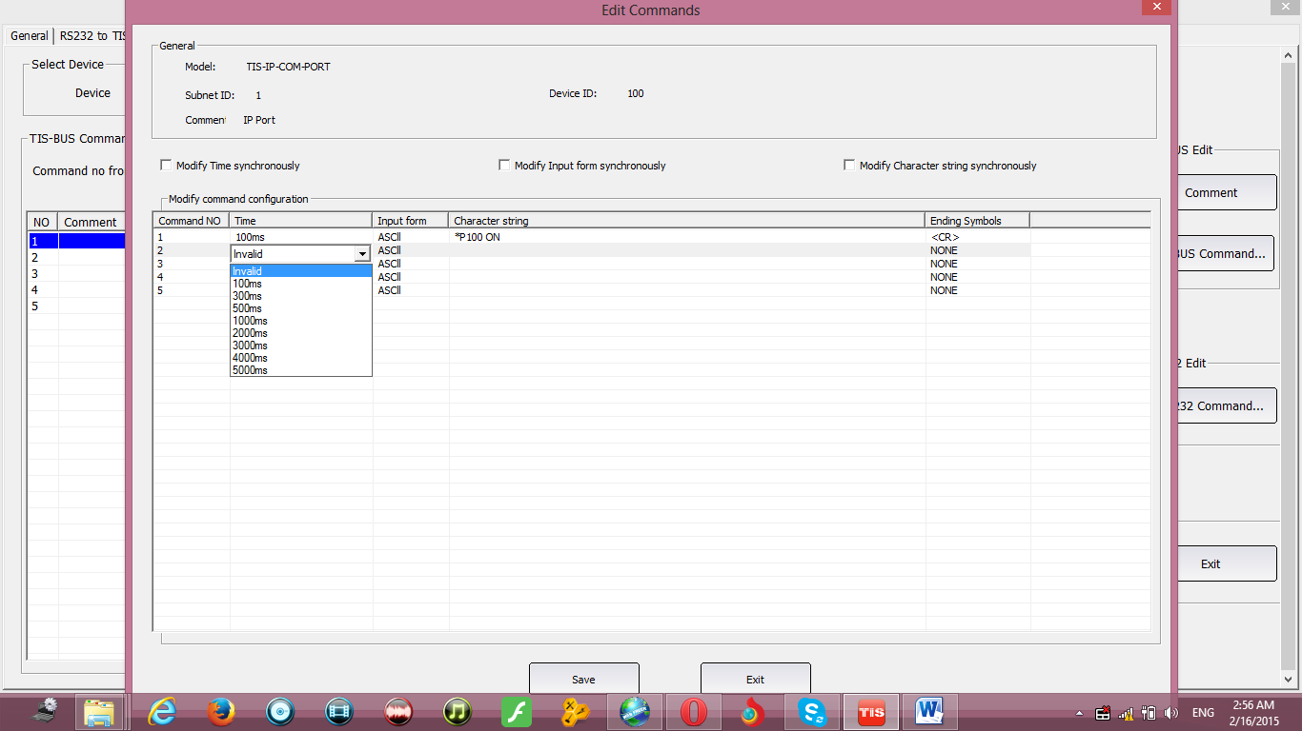

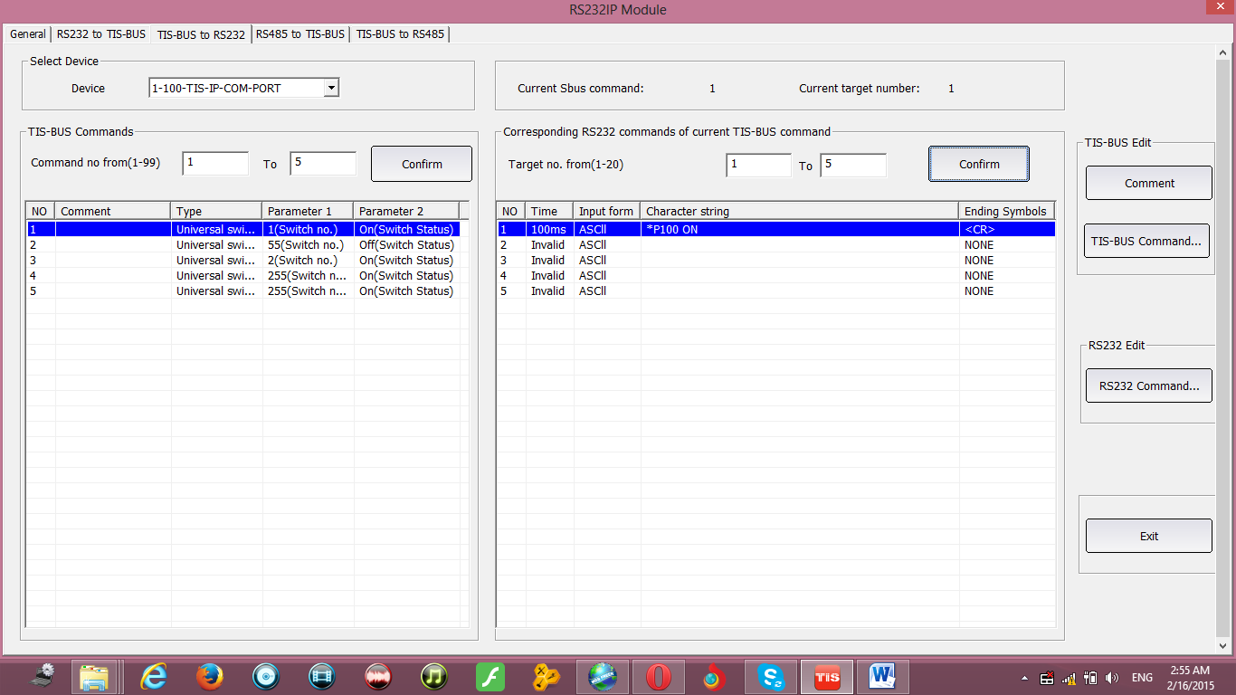
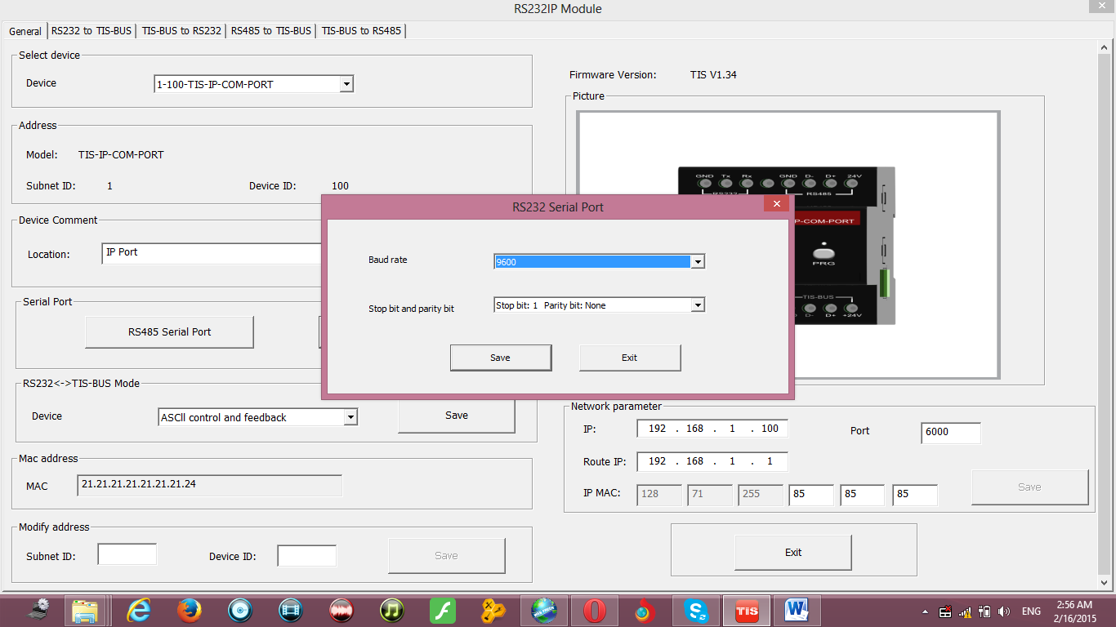

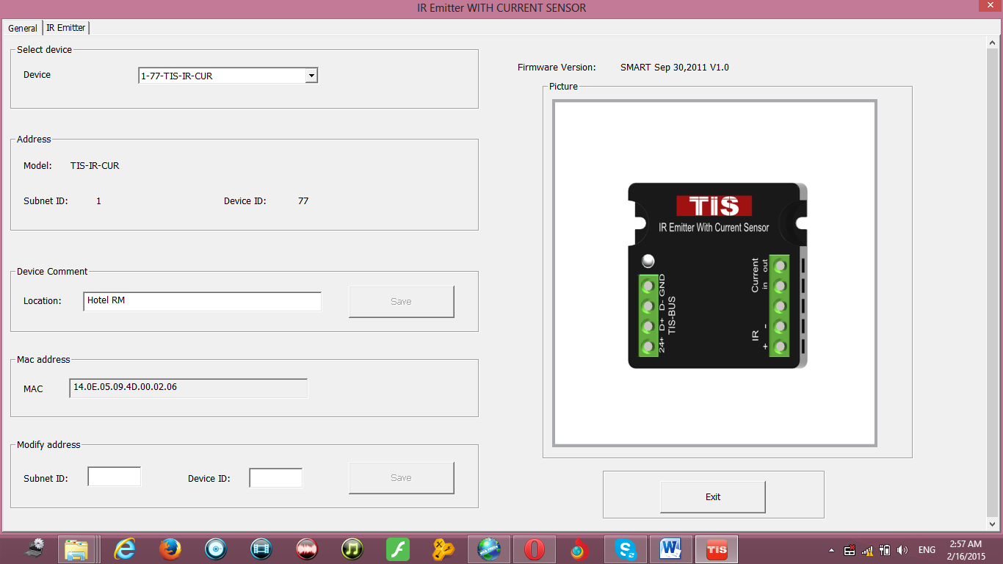
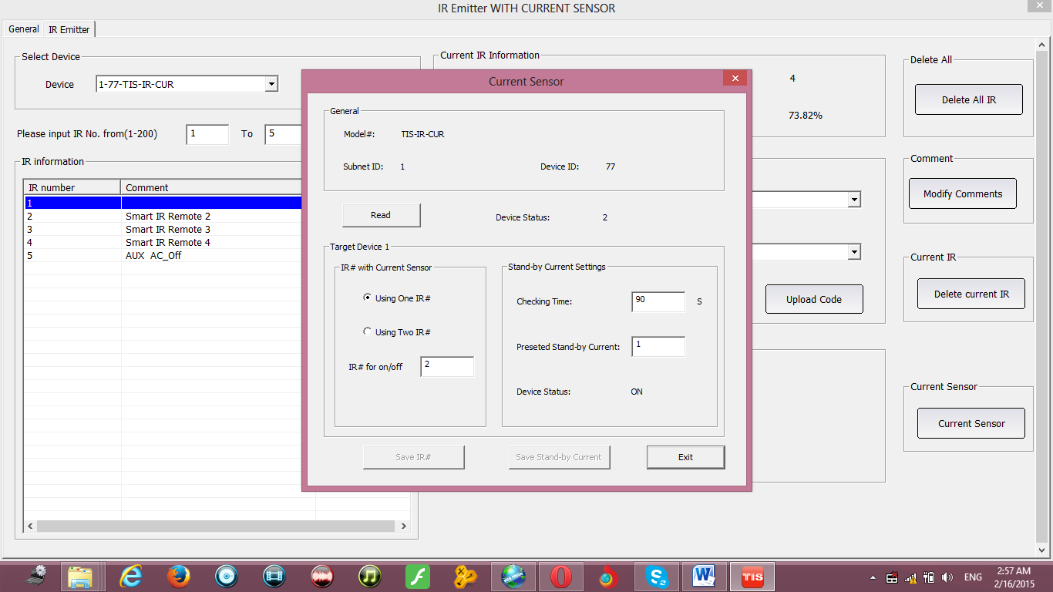

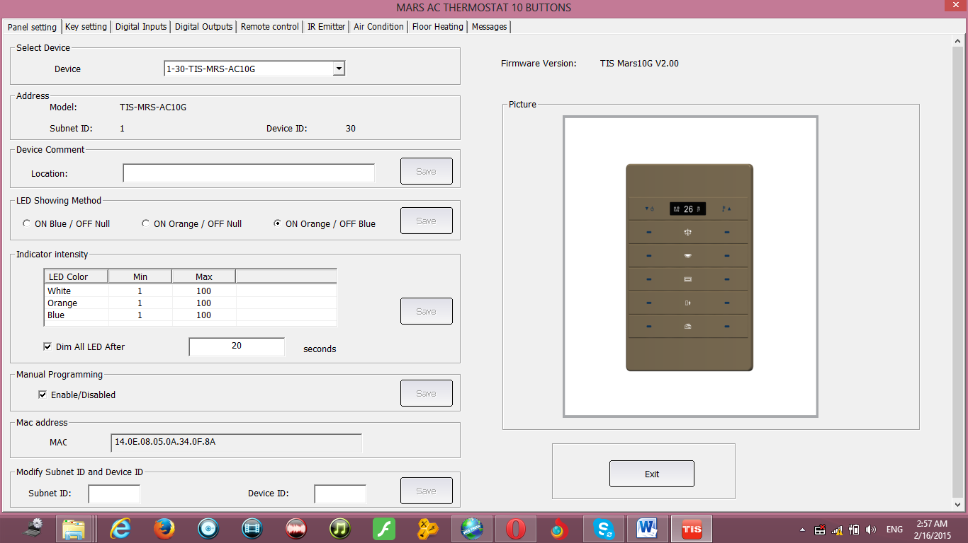

For more information about Programming and other helpful materials
Visit our website
www.tissmarthome.com

for HD film about programming visit sbus training page on youtube
www.youtube.com/user/sbustraining

